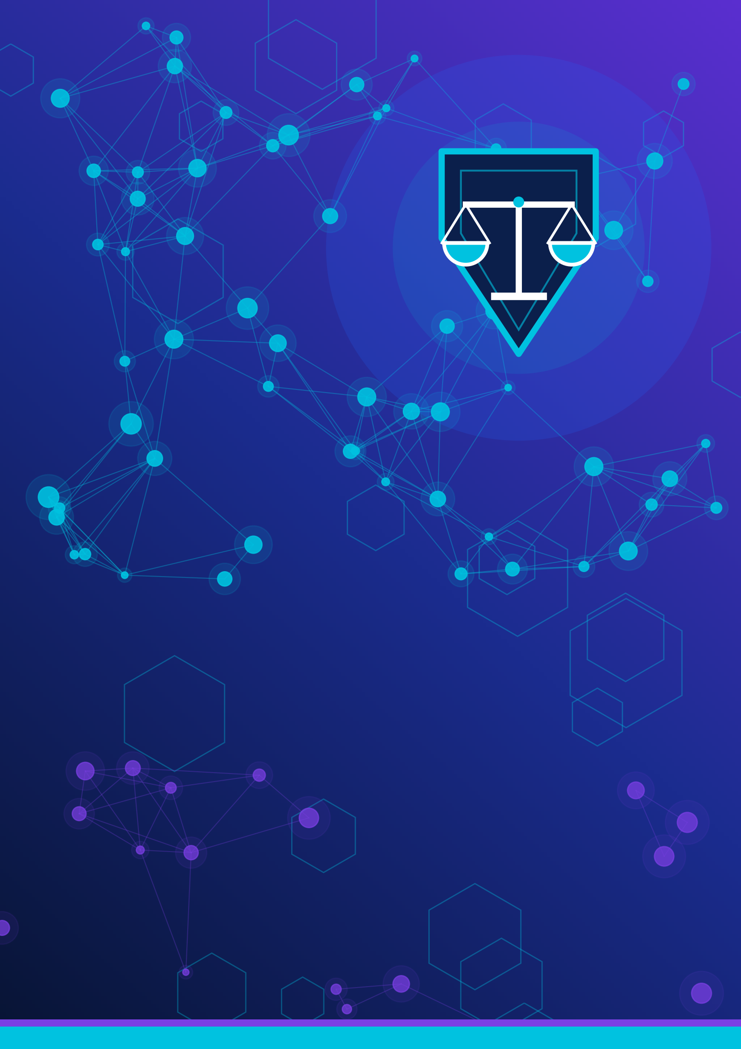

CLASS 11 | AI OLYMPIAD WORKBOOK
Responsible AI
Fair AI Challenge • Privacy in an AI World
MONTH 6 | UNIT 6

Name: | Class and section:
School: | Roll number:
Think. Question. Protect. Build responsibly.

About This Workbook
Read this first | How to get the most from Unit 6

Welcome to Unit 6: Responsible AI. In this unit you will explore two topics, Fair AI Challenge and Privacy in an AI World, and learn how to use AI in ways that are fair, safe and respectful. Every example and data set is fictional or generic, so you never need to share real passwords, photographs, addresses or other private information.

What you will be able to do
- Explain Responsible AI and its six key ideas: fairness, bias, transparency, accountability, safety and human oversight.
- Describe how bias enters AI through data, design and decisions, and use simple measures to detect and reduce it.
- Explain personal and sensitive information, digital footprints and how AI collects, processes, stores and uses data.
- Spot privacy risks in chatbots, facial recognition, voice assistants and online platforms, and practise safe habits.
- Check privacy settings and policies, understand consent and use basic cybersecurity.
- Describe the roles of students, developers, organisations and governments, and create a Responsible AI Safety Guide.

How the workbook is organised
Part | What is inside | Suggested time
1 Fair AI Challenge | Responsible AI, bias, real cases, bias detection lab, ethical decisions | Week 1 to 2
2 Privacy in an AI World | Data privacy, AI data journey, risks, safe practices, consent, settings, policies, privacy lab | Week 2 to 3
3 Responsible AI in Action | Roles, everyday use, case studies, debate, mini-project, personal checklist | Week 3 to 4
4 Practice and Assessment | Activities, puzzles, worksheets, MCQs, summary, glossary, 30-mark assessment, answer key | Week 4

Box guide
KEY IDEA | The most important idea in a section.
THINK ABOUT IT | A question to pause and reflect on.
SAFETY TIP | Practical advice to stay safe.
ACTIVITY | A hands-on task to complete.
KEEPING BALANCE | A reminder that AI also brings benefits.
IN A NUTSHELL | A short chapter summary.

Write in the lines and boxes provided. Use pencil for puzzles. Discuss with classmates, but always give your own reasons.

Table of Contents
Unit 6: Responsible AI | Month 6
PART 1: Fair AI Challenge
1.1 Introduction to Responsible AI
1.2 How Bias Enters AI Systems
1.3 Unfair AI Outcomes in the Real World
1.4 Identify, Reduce and Prevent AI Bias
1.5 Lab: Bias-Detection Exercises
1.6 Fairness Challenges and Ethical Decisions
PART 2: Privacy in an AI World
2.1 Data Privacy Basics
2.2 How AI Collects, Processes, Stores and Uses Data
2.3 Privacy Risks in AI Tools
2.4 Safe Practices for Using AI Tools
2.5 Data Protection, Consent and Cybersecurity
2.6 Privacy Settings and Privacy Policies
2.7 AI as a Privacy Protector
2.8 Privacy-Risk Identification Lab
PART 3: Responsible AI in Action
3.1 Who Is Responsible? Roles in Responsible AI
3.2 Using AI Fairly, Safely and Responsibly Every Day
3.3 Case Studies (Fairness and Privacy)
3.4 Group Discussion and Debate
3.5 Mini-Project: Responsible AI Safety Guide for Students
3.6 My Personal Responsible-AI Checklist
PART 4: Practice and Assessment
4.1 Classroom Activities
4.2 Puzzles and Challenges
4.3 Worksheet 1: Fairness and Bias
4.3 Worksheet 2: Privacy and Data Safety
4.3 Worksheet 3: Responsible AI in Practice
4.4 MCQ Challenge Round
4.5 Unit Summary and Concept Map
4.6 Revision Questions
4.7 Glossary
4.8 Unit 6 Assessment (30 marks)
4.9 Answer Key and Suggested Answers

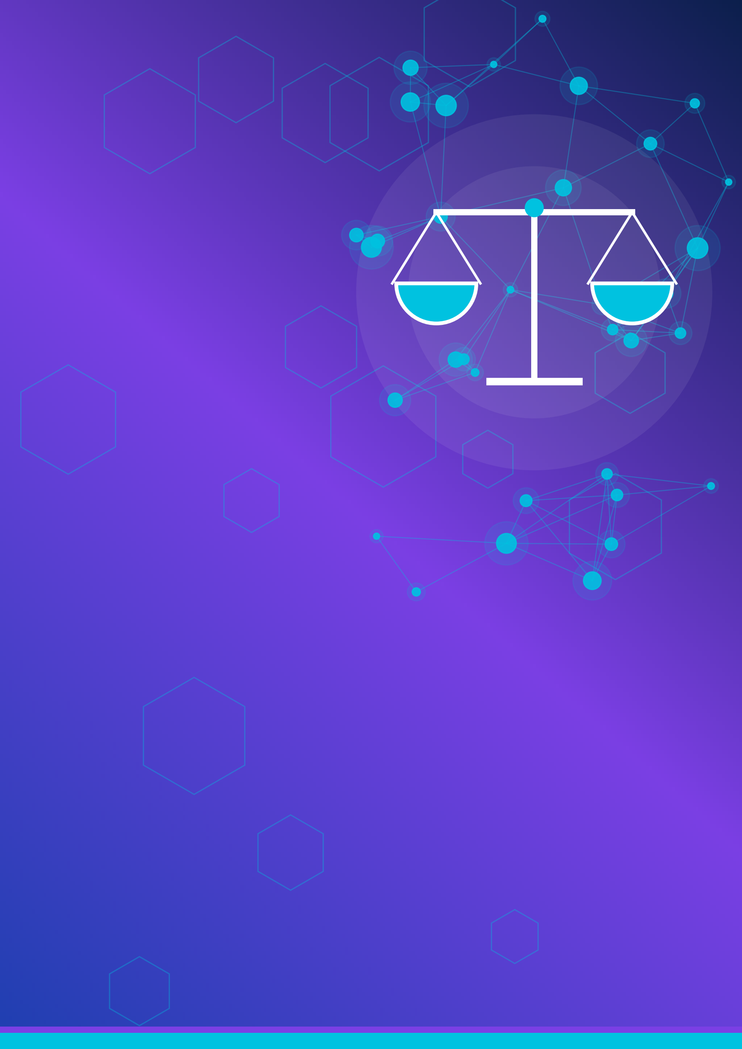

PART 1
Fair AI Challenge
Can a machine be fair? Let us find out.
1.1 Introduction to Responsible AI
1.2 How Bias Enters AI Systems
1.3 Unfair AI Outcomes in the Real World
1.4 Identify, Reduce and Prevent AI Bias
1.5 Lab: Bias-Detection Exercises
1.6 Fairness Challenges and Ethical Decisions

1.1 | Introduction to Responsible AI  Fair AI Challenge | Why AI needs a conscience (and a checklist)

Artificial Intelligence (AI) already helps decide which videos you watch, which route your map app suggests, which emails are marked as spam and, in some places, which job applications are shortlisted. AI learns patterns from data that humans created, using rules that humans designed. That means it can copy human mistakes, and do so very quickly and at a very large scale.
Responsible AI means designing, building and using AI so that it is useful, fair, safe, understandable and respectful of people's rights. It is not about being afraid of AI. Think of seat belts in a car: they do not stop you from travelling, they make travel safer.

Why does Responsible AI matter?
- Scale: one flawed rule in an AI system can affect millions of people at once.
- Speed: decisions are made in seconds, so mistakes spread before anyone notices.
- High stakes: AI is used in education, healthcare, jobs and finance, where decisions change lives.
- Hidden decisions: people may not even know AI was involved, so they cannot question it.
- Trust: people will use AI only if they believe it is fair, safe and honest.

Six key ideas of Responsible AI
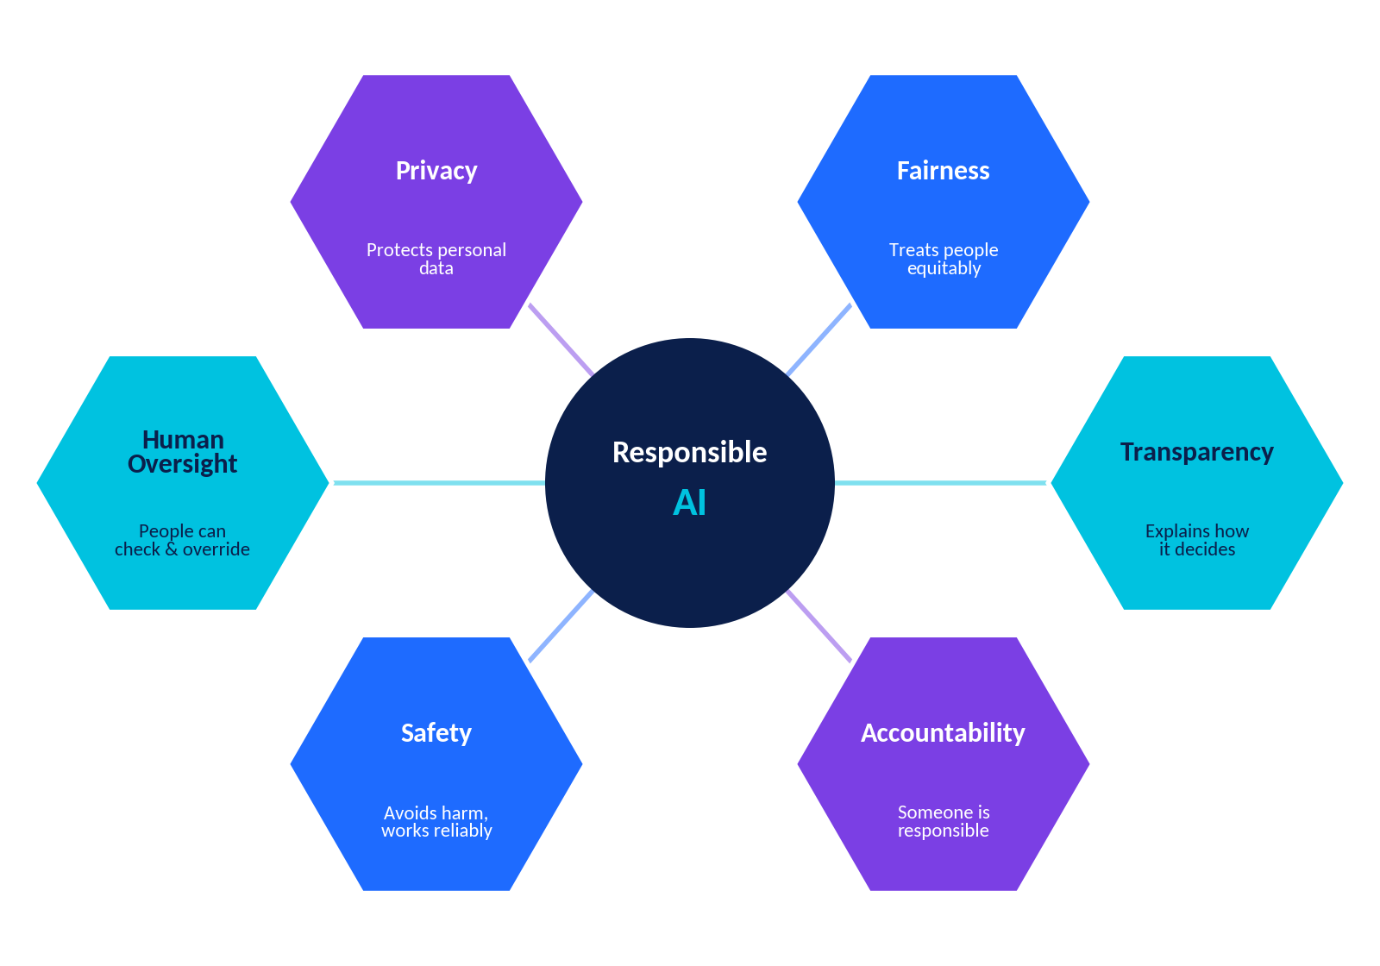
Figure 1.1: The six key ideas that support Responsible AI.
Concept | What it means | Student-friendly example
Fairness | AI treats people and groups equitably and does not put anyone at an unjustified disadvantage. | A scholarship AI should look at marks and effort, not at which area of the city a student lives in.
Bias | A systematic pattern that leads to unfair results for some people or groups. | A face-unlock feature that works well for some faces and poorly for others.
Transparency | Being open about when AI is used, what data it uses and how it reaches decisions, as far as possible. | An app labels a summary: "Written by AI using your quiz results."
Accountability | A named person or organisation is responsible for what the AI does and can fix harm. | A school names a teacher who reviews AI-flagged marks and handles appeals.
Safety | AI is tested, works reliably and avoids physical, emotional or financial harm. | A homework chatbot refuses dangerous instructions and suggests talking to a trusted adult.
Human oversight | People can monitor, question and override AI, especially for important decisions. | A doctor makes the final diagnosis after an AI tool flags a scan.

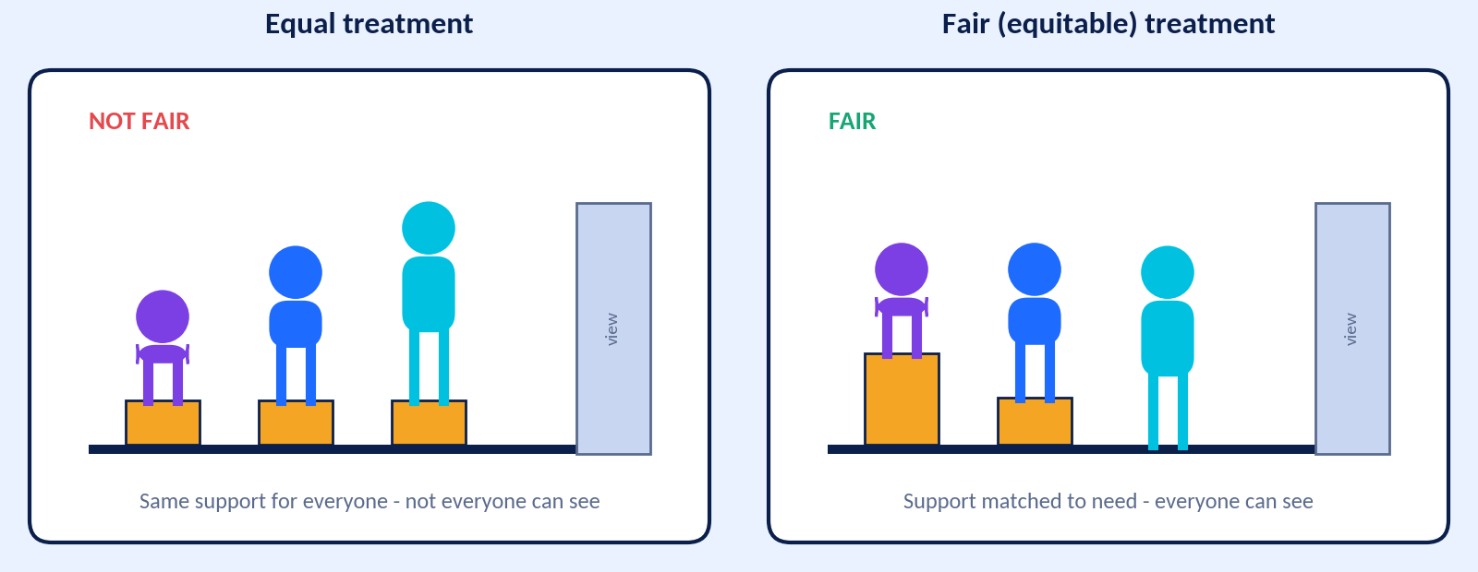
Figure 1.2: Fair does not always mean identical. Fair means everyone gets what they need to be treated well.
KEY IDEA
No AI system is completely fair or completely secure. Responsible AI is a continuing effort: test, measure, improve and listen to the people affected.

THINK ABOUT IT
Name one AI tool you used this week. Which of the six ideas matters most for it, and why?

IN A NUTSHELL
Responsible AI = fair, transparent, accountable, safe, privacy-respecting and under human oversight. It helps us keep the benefits of AI while reducing harm.

1.2 | How Bias Enters AI Systems  Fair AI Challenge | Data, design and decisions

An AI model does not have opinions or feelings. Yet it can still produce unfair results. Why? Because it learns from data and follows design choices made by people. Bias can slip in through three "doors": data, design and decisions. A useful saying is "bias in, bias out".
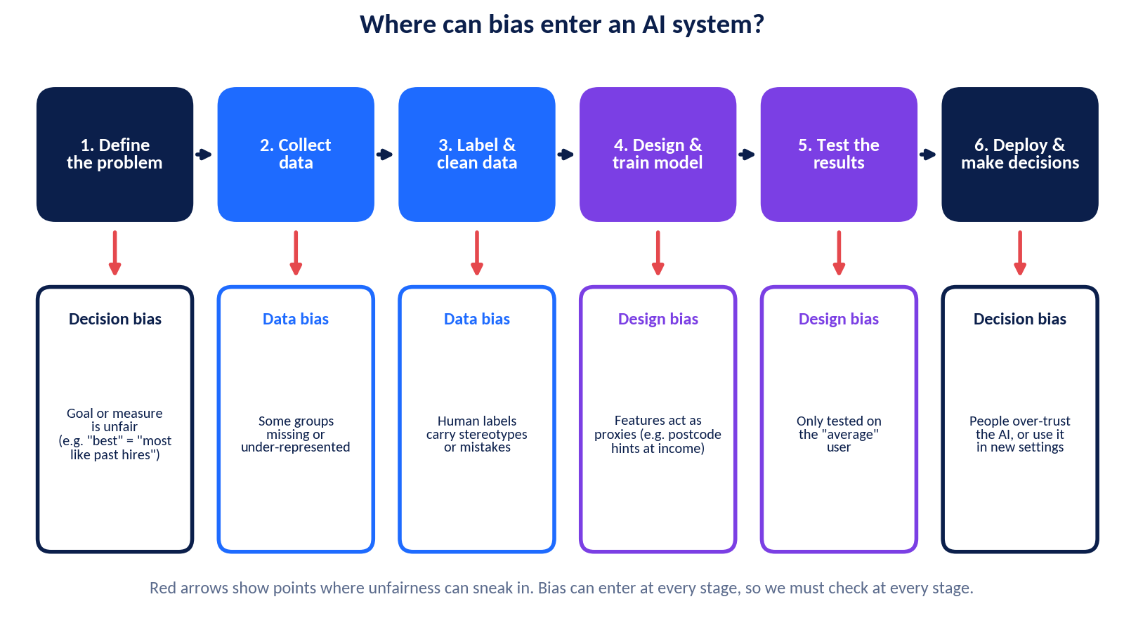
Figure 1.3: Bias can enter at every stage of an AI system's life.

Door 1: Data bias
Type | What goes wrong | Fictional example
Historical bias | Past data reflects an unfair past, and the AI learns it as "normal". | A company's old hiring data shows most hires came from one college. The AI learns that "that college = good".
Representation bias | Some groups are missing or very few in the data. | A speech assistant trained mostly on one accent mishears other accents.
Label bias | People who label data are inconsistent or use stereotypes. | Essays written in a regional style are labelled "poor" by tired reviewers.
Measurement bias | A weak stand-in measure is used for what we really care about. | "Number of clubs joined" is used to measure leadership, ignoring students who work after school.
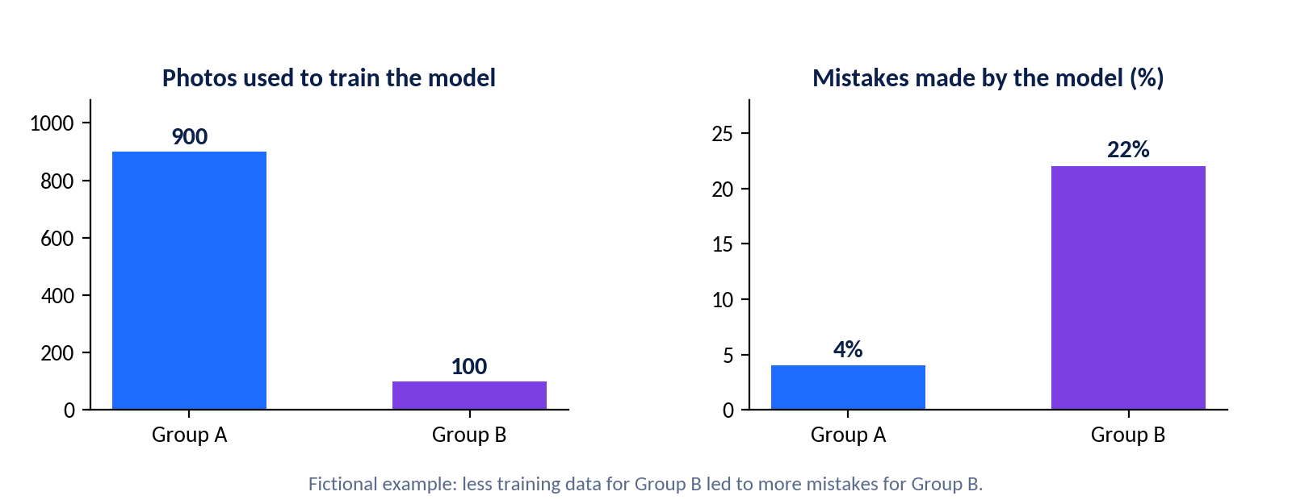
Figure 1.4: Fewer training examples for Group B led to more mistakes for Group B (fictional data).

Door 2: Design bias
Developers choose the goal, the input features, the settings and the success measure. A poor choice can build in unfairness. A common problem is a proxy: a feature that secretly stands in for something sensitive. For example, a home pin code can hint at family income, and phone model can hint at wealth. Removing a sensitive column such as gender does not always remove bias, because proxies can still carry the same signal.

Door 3: Decision bias
Even a well-built AI can cause harm if people use it carelessly. Automation bias is the habit of trusting a computer's answer without checking it. A feedback loop happens when the AI's output changes the data it will learn from next. For example, a fictional delivery app sends fewer offers to Neighbourhood X because few orders were recorded there. Fewer offers lead to fewer orders, which leads to even fewer offers.
KEY IDEA
Bias is usually not intentional. It often appears because nobody checked who was missing from the data, what a feature really stands for, or how results are used.

QUICK EXERCISE
Spot the door. Write Data, Design or Decision next to each fictional situation.
Situation |  | Door
a) A plant-disease app was trained on photos from only one farm region.
b) A scholarship AI uses "distance from city centre" as an input.
c) A teacher accepts every AI-suggested grade without reading the essays.
d) Labellers rated friendly-sounding voices as "more professional" in a call-centre dataset.

IN A NUTSHELL
Bias can enter through data (what the AI learns from), design (how it is built) and decisions (how people use it). Check all three.

1.3 | Unfair AI Outcomes in the Real World  Fair AI Challenge | Education, healthcare, recruitment and more

Unfair AI outcomes have appeared in many fields. The table below summarises a few well-known real cases in simple form and some fictional examples we created for practice. Real cases are labelled and described briefly; the lessons matter more than the details.
Field | What happened | Lesson
Recruitment (real, reported 2018) | News reports said a large online retailer stopped using an experimental résumé-screening tool. It had learned from past hiring data dominated by men and rated women's résumés lower. | Historical data can carry old unfairness into new decisions.
Education (real, UK 2020) | When exams were cancelled during COVID-19, a statistical method was used to adjust predicted grades. Many students received lower grades than their teachers predicted, and the grades were later replaced by teacher assessments. | Group-level methods can harm individual students. People need a way to appeal.
Healthcare (real research, 2019) | Researchers studied a widely used hospital risk tool in the USA. It used past healthcare spending as a stand-in for health need. Because less had been spent on Black patients with the same level of illness, their needs were under-estimated. | A proxy measure can hide unfairness. Always ask what a feature really measures.
Face analysis (real research, 2018) | The "Gender Shades" study found that some commercial face-analysis systems made many more errors for darker-skinned women than for lighter-skinned men. | Test performance separately for each group, not only overall.
Finance (fictional) | "QuickLoan AI" offers lower credit limits to applicants from Hillside Colony, even when income and repayment history match applicants from other areas. | Location can act as a proxy for income or community.
Speech (research finding, general) | Studies have found that some speech-recognition tools make more errors for certain accents and dialects. | Collect diverse voices and test with many users.
School tools (fictional) | "ExamGuard AI" marks students as "suspicious" more often when their home internet is slow, because the video freezes. | A tool can punish students for conditions they cannot control.

KEEPING BALANCE
AI also does a great deal of good: it helps doctors spot disease earlier, translates languages and helps farmers predict crop problems. Learning about unfair cases is not about fearing AI. It is about keeping the benefits and reducing the harm. AI can even help find unfairness when it is used to audit decisions.

Pillar Detective
For each case, decide which of the six key ideas (fairness, transparency, accountability, safety, human oversight, privacy) was most missing, and explain in one line.
Case | Most-missing idea | Why?
Recruitment tool
UK grading 2020
Hospital risk tool
ExamGuard AI (fictional)

IN A NUTSHELL
Real cases show the same patterns: unrepresentative data, weak proxies, no testing across groups, and no easy way to challenge results.

1.4 | Identify, Reduce and Prevent AI Bias  Fair AI Challenge | Practical tools for fairer AI

Fixing bias is like keeping a school garden healthy: you check what is growing, remove the weeds and prepare the soil so problems do not return. In AI we call these three jobs identify, reduce and prevent.
Stage | Ways to do it | Simple example
IDENTIFY (find it) | • Look at the data: who is included and who is missing?  • Compare results for each group, such as selection rate and error rate.  • Look for proxy features.  • Listen to complaints and feedback.  • Test with diverse users. | Compare the share of Group A and Group B applicants selected by a scholarship AI.
REDUCE (fix it) | • Add more representative data.  • Re-balance or re-weight the data.  • Remove or adjust proxy features.  • Set fairness goals before training.  • Add human review for borderline or high-stakes cases. | Add 500 more voice samples from under-represented accents and retest.
PREVENT (stop it returning) | • Build diverse teams.  • Use an ethics checklist at the start of every project.  • Document the data and model (like a nutrition label).  • Monitor results regularly after release.  • Offer an easy appeal route. | A school reviews its AI tools every term and publishes a short report.

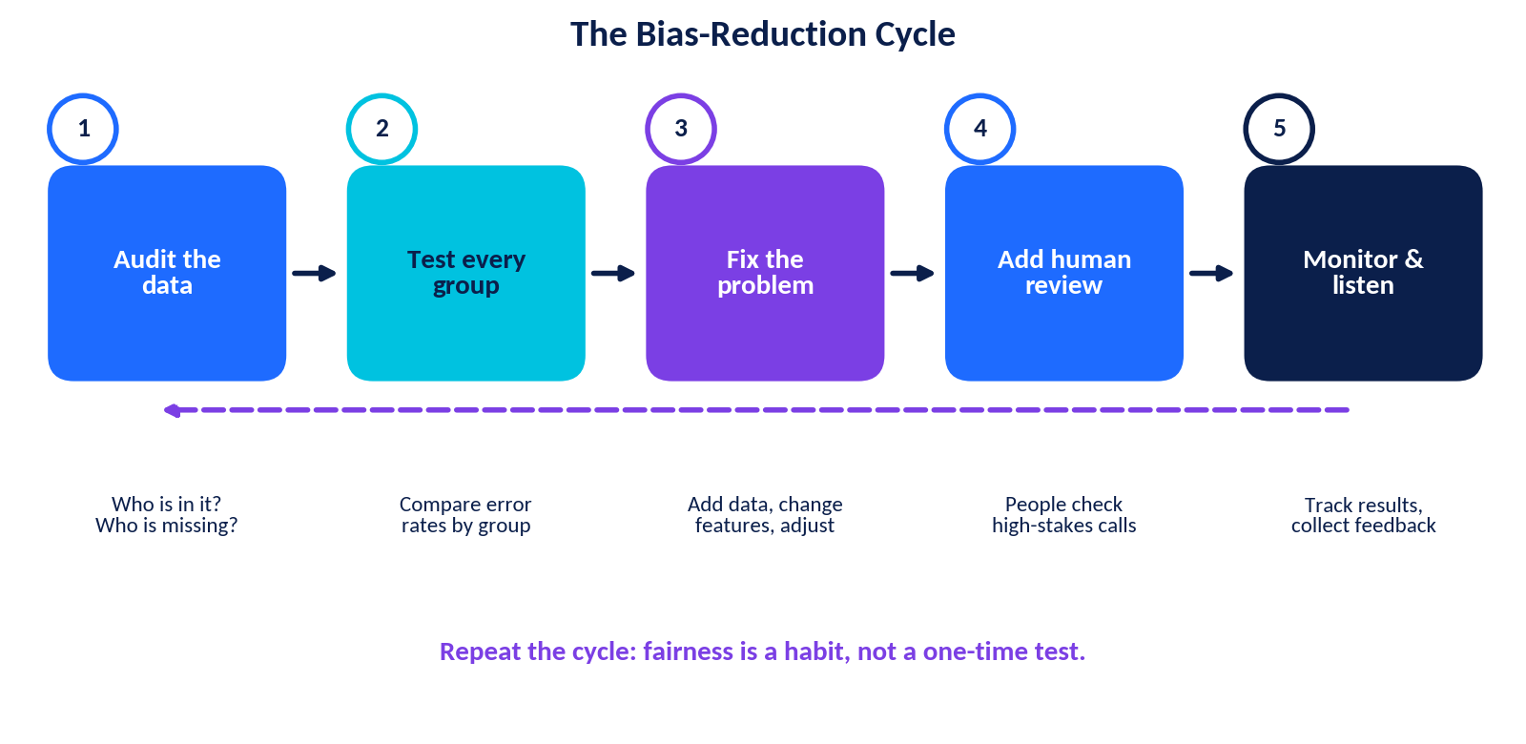
Figure 1.5: The bias-reduction cycle is repeated again and again.

Two simple fairness measures
- Selection rate = (number selected ÷ number who applied) × 100. Calculate it for each group and compare.
- Error rate = (number of wrong results ÷ number of tests) × 100. A much higher error rate for one group is a warning sign.
- Rule of thumb: in some hiring audits, if one group's selection rate is less than 80% of the highest group's rate, people look more closely. This is a warning sign, not proof of unfairness.
KEY IDEA
Trade-offs are real. Different ideas of fairness can conflict, and fixing one problem can create another. There is rarely one perfect fix, so we explain our choices, test again and keep humans involved.

FAIRNESS AUDIT CHECKLIST
Tick the boxes your team could honestly say "yes" to before using an AI tool for choosing students.
☐ We know where the data came from and who is missing.
☐ We compared results for different groups.
☐ We checked for proxy features such as pin code.
☐ A named person is accountable and a human reviews close calls.
☐ Students can ask questions and appeal.

IN A NUTSHELL
Identify bias by comparing groups, reduce it with better data and design, prevent it with teams, checklists, monitoring and appeals.

1.5 | Lab: Bias-Detection Exercises  Fair AI Challenge | Fictional data, real thinking

All data here is fictional. Use a calculator if you like and show your working in the boxes.

Worked example
A fictional AI shortlists applicants for a coding camp. Out of 100 applicants from Group A, 70 are selected. Out of 100 from Group B, 40 are selected.
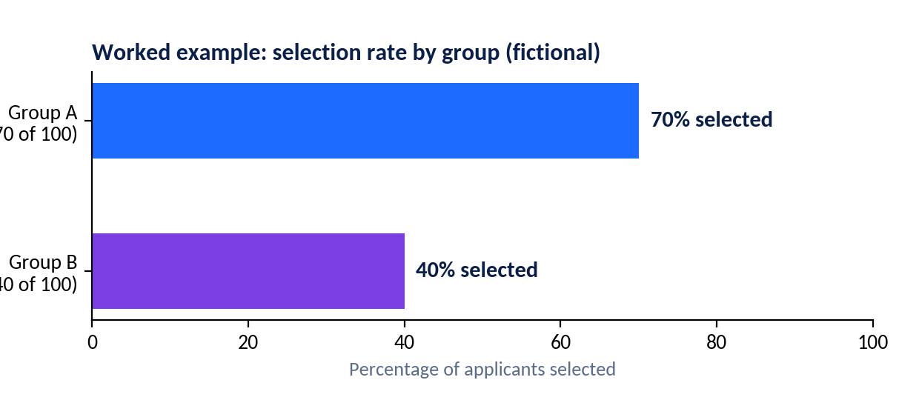
Selection rates: A = 70%, B = 40%. Ratio = 40 ÷ 70 = 0.57, or 57%. This is below 80%, so the system should be examined more closely.

Exercise A: Nova Scholarship Selector
A fictional AI selects students for a scholarship. Complete the table, using the highest selection rate as the comparison.
Student group | Applied | Selected | Selection rate (%) | Ratio to highest (%) | Flag if below 80%?
Urban North | 80 | 48
Urban South | 60 | 24
Rural | 40 | 8
Boarding hostel | 20 | 12
Which groups are flagged? Suggest two possible reasons.

Exercise B: SmartAttend face-check
A fictional app marks attendance using face matching. Testers checked photos from three groups of students.
Group | Photos tested | Wrong matches | Error rate (%)
Group 1 | 200 | 10
Group 2 | 200 | 12
Group 3 | 100 | 20
Which group is served least well? How many times higher is its error rate than Group 1? List two actions the developers should take.

Exercise C: Proxy hunt
A fictional "Campus Club Recommender" uses the features below. Tick the column that fits best.
Feature | Fair to use for the goal | Possible proxy / needs care | Sensitive
Marks in Science
Home pin code
Parent's job
Favourite subjects
Gender
Attendance %
Phone model
Number of siblings

Exercise D: Fix-it plan
Using Exercise A, write a three-step plan to make the selector fairer.

1.6 | Fairness Challenges and Ethical Decisions  Fair AI Challenge | Discuss, decide, justify

Ethical decisions are rarely "right or wrong" like a maths answer. We need a method. Use the STOP framework for every dilemma in this chapter.
Letter | Question to ask | Your notes
S: Stakeholders | Who is affected? Who is not in the room?
T: Think harms and benefits | What could go wrong? What good could happen? Who benefits most?
O: Options | What are at least three possible choices?
P: Pick and plan | Which option is best, and how will we check and fix it later?

Fairness Challenge 1: Design a fair rule
The school library will use a fictional "Reading Prize AI" to choose 10 winners from 200 students. In groups of four, decide which inputs (for example books read, reviews written, library visits, class, home Wi-Fi) are fair and which are not. Explain how you would test that the system does not favour any group.

Fairness Challenge 2: Three dilemmas
Dilemma | Your decision and reason
Dilemma 1: The slow-internet flag. An online exam tool flags "suspicious behaviour" more often for students with slow internet. The school has no other way to supervise. Do you use it? On what conditions?
Dilemma 2: The better tutor. An AI tutor explains concepts better to students who write fluent English. Others get confusing answers. What should the developers and the school do?
Dilemma 3: The 70% problem. A health app is 95% accurate overall but only 70% accurate for one group. The launch date is tomorrow. Release, delay or release with limits?

Group discussion
Roles: Facilitator (keeps order), Recorder (writes key points), Timekeeper, Reporter (shares with the class). Discuss for 10 minutes, then report in 1 minute.
- Is it fair to use an AI to decide something important about you if you cannot see how it decided?
- Who should be accountable when an AI makes an unfair decision: the developer, the school or the user?
- Should AI be allowed to make final decisions about students, or only to assist teachers?
- Can AI be fairer than humans? When might it be, and when might it not be?
Group conclusion in two sentences:

IN A NUTSHELL
Use STOP to slow down. Ethical choices need stakeholders, honest trade-offs, several options and a plan to check results later.

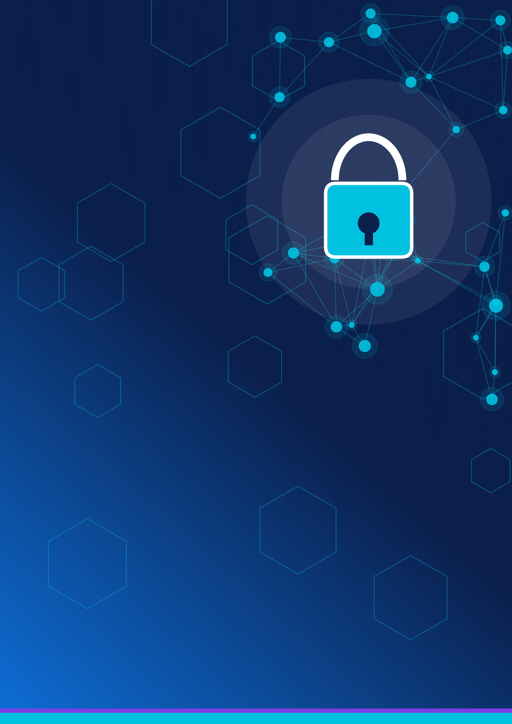

PART 2
Privacy in an AI World
Your data, your choices, your digital footprint.
2.1 Data Privacy Basics
2.2 How AI Collects, Processes, Stores and Uses Data
2.3 Privacy Risks in AI Tools
2.4 Safe Practices for Using AI Tools
2.5 Data Protection, Consent and Cybersecurity
2.6 Privacy Settings and Privacy Policies
2.7 AI as a Privacy Protector
2.8 Privacy-Risk Identification Lab

2.1 | Data Privacy Basics  Privacy in an AI World | Personal data, sensitive data and digital footprints

Data privacy is your right and your ability to control who collects your information, how it is used and who can see it. AI systems run on data, so privacy matters more than ever. Privacy is not about having something to hide. It is about having control over your own life.

Types of information
Type | Meaning | Examples (fictional) | Care level
Personal information | Anything that can identify you, directly or when combined with other facts. | Name, photo, phone number, email, school ID, IP address, voice | Medium
Sensitive information | Information that could cause serious harm, unfair treatment or distress if exposed. | Health records, fingerprint or face scan, bank details, passwords, precise live location, government ID numbers | High
Confidential information | Information that a person or organisation must keep private. | Unreleased exam papers, school records, company files | High
Anonymous data | Data with identifying details removed. It can sometimes still be re-identified if combined with other data. | "Average marks of Class 11 = 68%" | Lower, but not zero

Your digital footprint
Your digital footprint is the trail of data you leave online. An active footprint is what you share on purpose, such as posts, comments and forms. A passive footprint is collected in the background, such as location history, cookies, device details and what you watch.
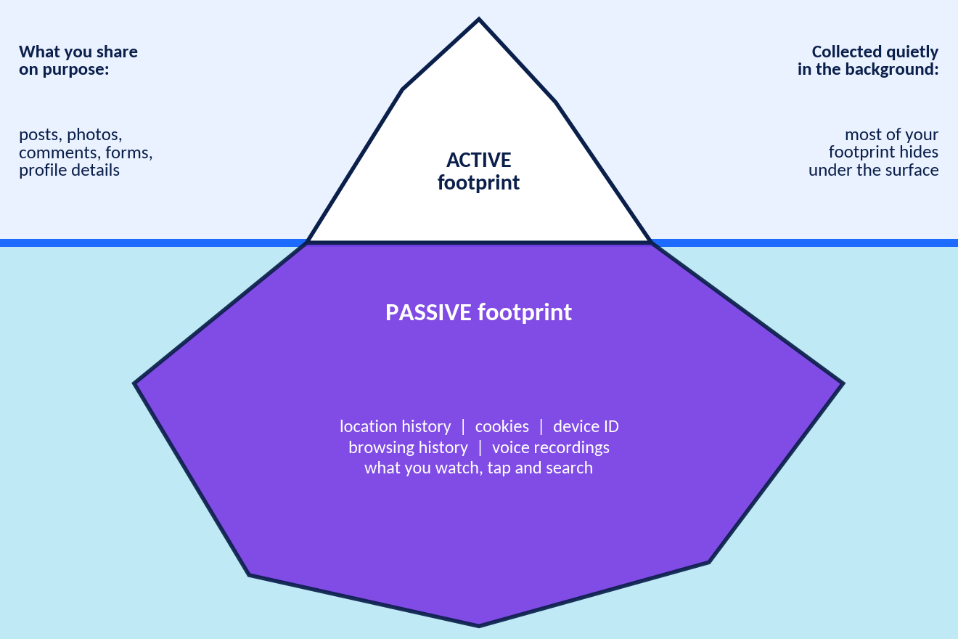
Figure 2.1: Most of your digital footprint is below the surface.

Why does privacy matter?
- Safety: strangers should not know where you are or when your home is empty.
- Identity: leaked details can be used for scams or impersonation.
- Fairness: collected data can be used to profile you or limit opportunities.
- Future: old posts and screenshots can last longer than you expect.
- Freedom: knowing you are watched can change how you speak and act.
FOOTPRINT AUDIT
Meera is a fictional student. Mark each action A (active) or P (passive) footprint.
Meera's action |  | A or P
Posts a photo of her sports day trophy
Her phone saves her location history all day
A shopping site stores cookies to remember her browsing
She comments on a classmate's video
Her smart speaker keeps a transcript of her questions

IN A NUTSHELL
Personal data identifies you, sensitive and confidential data need extra care, and your digital footprint has an active and a passive part.

2.2 | How AI Collects, Processes, Stores and Uses Data  Privacy in an AI World | Following the data journey

To understand privacy risks, follow the data journey. At every step, ask a privacy question.
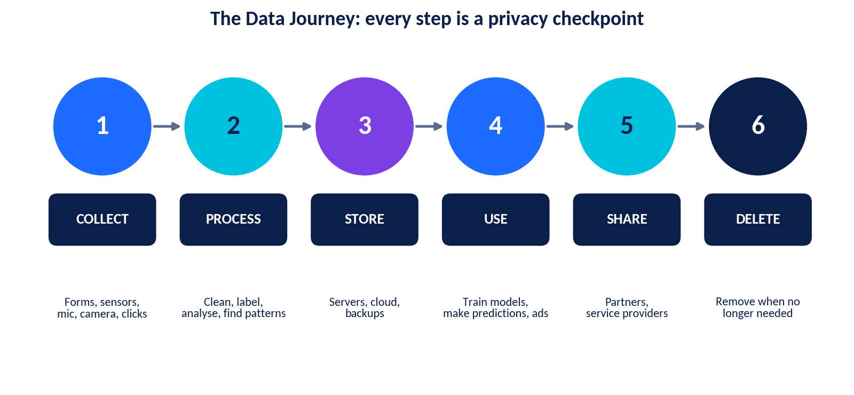
Figure 2.2: The data journey from collection to deletion.

How AI gets data
Way of collecting | Meaning | Example
Directly from you | You type, speak, upload or tick something. | Typing a prompt, uploading a photo, filling a sign-up form
Observed | The system watches what you do. | Clicks, watch time, location, camera or microphone input
Inferred | AI guesses things about you from patterns, even if you never said them. | Guessing your interests, mood or likely age from your activity
Obtained from others | Data comes from partners, public sources or purchases. | A shop shares purchase data with an advertising partner

What happens next
- Process: data is cleaned, labelled and analysed. Some data is used to train a model; some is used when the model answers you.
- Store: data is kept on servers or in the cloud, often with backups. Longer storage means more chance of a breach.
- Use: to give you the service, improve AI, personalise, advertise or detect fraud. Some services use chats to improve models unless you opt out. Policies differ, so check the settings.
- Share: with service providers or partners, sometimes with rules, sometimes less clearly.
- Delete: responsible organisations remove data when it is no longer needed. Ask whether you can request deletion.
KEY IDEA
Data minimisation means collecting and keeping only what is needed for a clear purpose. A study app that needs only a nickname and class should not ask for your home address.

FOLLOW THE DATA
"StudyBuddy AI" is a fictional homework helper. Trace the data and fill in the table.
Stage |  | What data might be involved? | One privacy question to ask
Collect
Process
Store
Use
Share / delete

IN A NUTSHELL
AI collects data directly, by observing and by inferring. Each stage (collect, process, store, use, share, delete) needs its own privacy check.

2.3 | Privacy Risks in AI Tools  Privacy in an AI World | Chatbots, faces, voices and platforms

Most AI tools are helpful and many are built with good protections. Still, each type of tool has particular privacy risks. Knowing them helps you make informed choices, not fearful ones.
Tool | How data is involved | Main privacy risks | Smart habit
AI chatbots | Your messages and uploads are processed, and may be stored or used to improve the service depending on its rules. | Oversharing personal or confidential details; chat history seen on a shared device or by a hacker. | Use sample data, keep names and IDs out, review settings, delete history.
Facial recognition | A face is converted into a numeric "faceprint" and compared with others. | Biometric data cannot be changed like a password; tracking without consent; wrong matches, especially if poorly tested. | Ask where and why it is used; prefer opt-in; know your rights.
Voice assistants | A device listens for a wake word and may send audio to the cloud. | Accidental activation; stored recordings; voice can identify you. | Review and delete voice history; mute the mic; avoid private talk nearby.
Online platforms and recommendation apps | Likes, watch time, location and searches are used to personalise and advertise. | Profiling; sharing with advertisers; public posts being reused. | Tighten settings; limit permissions; think before posting.
AI photo, voice and video tools | Photos and voices are uploaded to create new images or audio. | Misuse of your image; deepfakes (fake but realistic media); using other people's photos without permission. | Never upload others' images without consent; report misuse to a trusted adult.

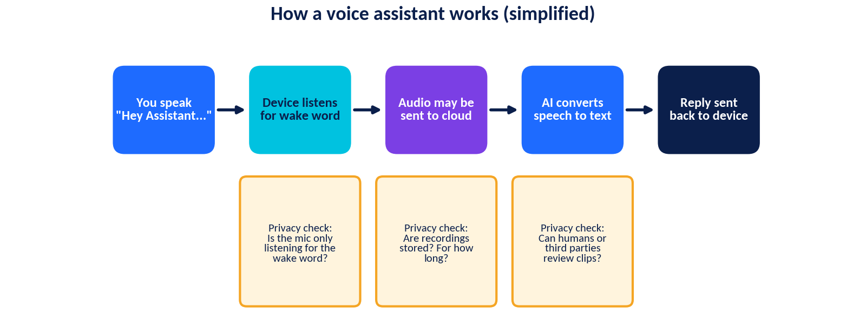
Figure 2.3: A voice assistant has several privacy checkpoints.

Six types of privacy risk to remember
Oversharing  Telling too much | Tracking and profiling  Building a picture of you | Data breach  Stored data is stolen or leaked
Re-identification  Anonymous data linked back to you | Misuse  Scams, impersonation, deepfakes | Loss of control  Not knowing who has your data

RISK RATING
Rate each tool for how much personal data it may touch (1 = very little, 5 = a lot) and add one reason.
Tool |  | Rating (1-5) | Reason
A calculator app (offline)
A smart speaker in the bedroom
A photo-aging AI app
A school-approved AI tutor

IN A NUTSHELL
Chatbots, face recognition, voice assistants and platforms each use data differently. Check what is collected, how long it is kept and who can see it.

2.4 | Safe Practices for Using AI Tools  Privacy in an AI World | Share smart, stay in control

A simple rule: before you type, upload or speak, ask "Would I be comfortable if a stranger saw this?" If the answer is no, do not share it.
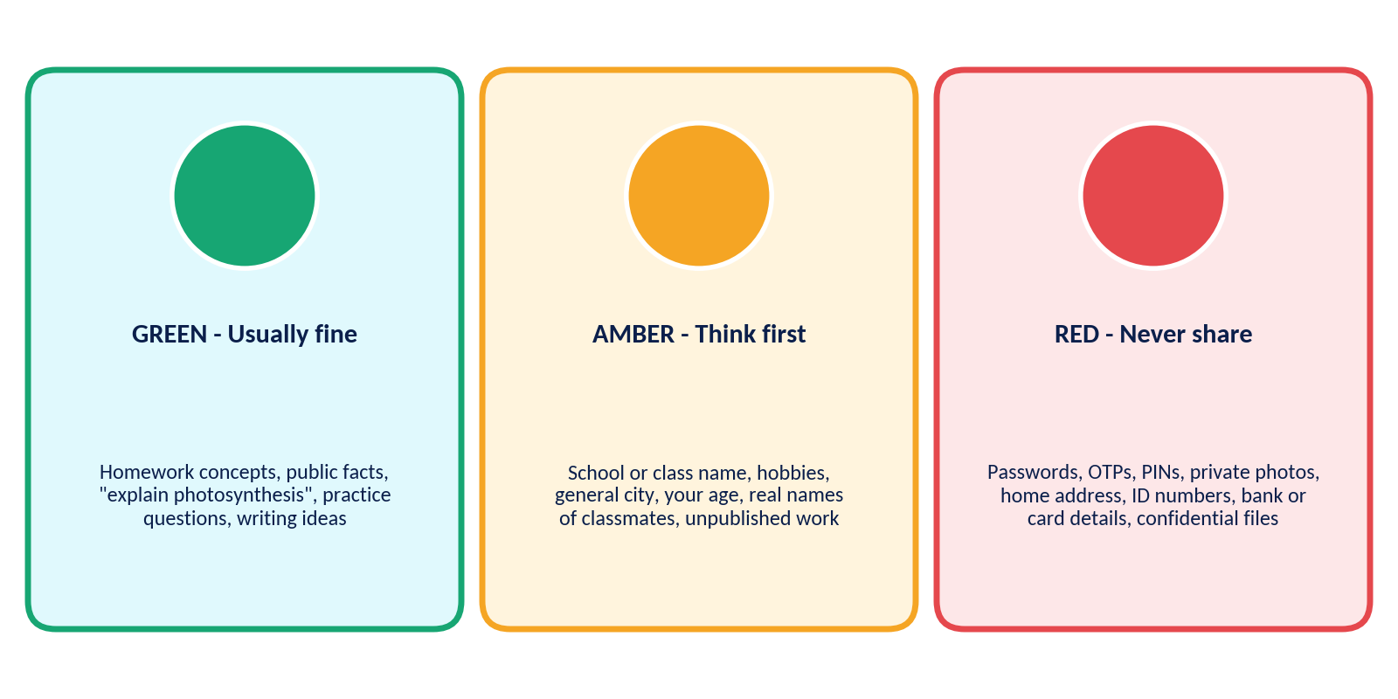
Figure 2.4: The traffic-light guide for sharing with AI tools.

Never share these with an AI tool
Never share | Why it is risky
Passwords, PINs and OTP codes | Anyone with them can take over your account. Real services never ask for them in a chat.
Private photographs (yours or other people's) | They can be stored, copied or misused, including for fake images.
Home address, live location, daily routine | This can show strangers where you are and when you are alone.
ID numbers, bank or card details | These can be used for fraud and are very hard to replace.
Confidential school, family or company files | You may be breaking rules, and you cannot control where the content goes.
Other people's personal details | Friends have a right to privacy too. Ask permission first.

Everyday safe habits
- Use fake or sample details when practising ("Student A, City X").
- Remove names and numbers before pasting text into a chatbot.
- Use school-approved tools whenever possible, and follow your school's AI rules.
- Check important answers with a reliable source, because AI can sound confident and still be wrong.
- Log out on shared devices and keep your device updated.
- Ask a trusted adult when an app asks for something unusual.
SAFETY TIP
If you overshare by mistake: (1) stop, (2) delete what you can, (3) change any password involved, (4) tell a trusted adult, and (5) report the problem to the app. Mistakes happen. Acting quickly helps.

REWRITE CHALLENGE
Rewrite it safely. Each fictional prompt below shares too much. Rewrite it so the AI can still help.
Unsafe prompt (fictional) |  | Safe rewrite
"I am Riya Sharma, 12 Lotus Road. Help me write a complaint to my landlord with my phone 98765-00000."
"Here is my school login: user riya_11, password blue123. Why can't I open my grades?"
"Fix this email to my teacher. Here are my friend Arun's marks and his medical reason for being absent."

IN A NUTSHELL
Share only what is needed, use sample data, and never share passwords, OTPs, private photos, addresses or confidential files.

2.5 | Data Protection, Consent and Cybersecurity  Privacy in an AI World | Rules, permission and everyday security

Data protection and responsible data use
Data protection means the rules and technical steps that keep personal data safe and make sure it is used lawfully. Many laws share similar ideas, such as the EU's General Data Protection Regulation (GDPR) and India's Digital Personal Data Protection Act, 2023, which also includes special provisions for children's data. Laws differ by country, so ask your teacher what applies where you live.
Principle | In simple words
Purpose and fairness | Use data only for the purpose you told people about.
Data minimisation | Collect only what you need.
Accuracy | Keep data correct and up to date.
Storage limitation | Do not keep data longer than needed.
Security | Protect data from loss, theft and misuse.
Accountability | Be able to show you follow the rules.

Consent
Good consent is freely given (you can say no), informed (you know what happens), specific (for a clear purpose) and easy to withdraw. Young people may need a parent or guardian's permission for some services. Watch out for dark patterns: pre-ticked boxes, hidden "decline" buttons or messages that pressure you to accept.
CONSENT OR NOT?
Tick Yes if consent is properly given and No if it is not. Give a one-line reason.
Fictional scenario |  | Yes / No | Reason
A form has "Share my data with partners" already ticked.
A school asks your parent to sign a clear photo-permission form for a poster.
A game will not start unless you allow access to all your contacts.
An app explains in plain words what it collects and lets you choose "No thanks".

Basic cybersecurity habits
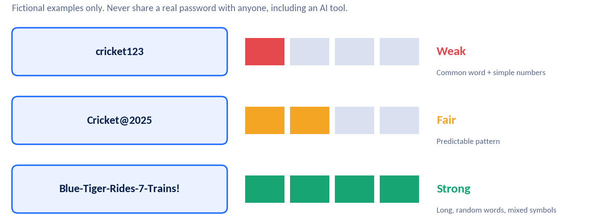
Habit | What to do
Strong, unique passwords | Use long passphrases (several random words), different for every account. A password manager can help.
Two-factor authentication | Add a second step, such as a code. Even if a password leaks, the attacker is stopped.
Software updates | Install updates; they fix known security holes.
Spot phishing | Check the sender, hover over links, be wary of urgency ("Act now!") and never share codes.
Careful on public Wi-Fi | Avoid logging into sensitive accounts, or use a trusted secure connection.
Back up and log out | Keep copies of important files and sign out on shared devices.

SAFETY TIP
AI can now copy voices and write very convincing messages. If a message or call asks for money, codes or secrets, verify it using another channel (for example, call the person on a number you already know).

IN A NUTSHELL
Data protection is about lawful, minimal, secure use of data. Real consent is free, informed, specific and withdrawable. Strong passwords, two-factor authentication and phishing awareness keep you safer.

2.6 | Privacy Settings and Privacy Policies  Privacy in an AI World | Take control in five minutes

How to check your privacy settings
Settings menus differ, but look for sections called Privacy, Security, Data controls, Permissions or Account.
Check this | Why it matters | Safer choice
Chat history and "improve the model" options | Controls whether your conversations may be kept or used for training. | Turn off if possible; delete old chats.
Location | Shows where you are and where you go. | "While using the app" or "Never".
Microphone, camera, photos | Gives apps access to sensitive content. | Allow only when needed; ask each time.
Contacts | Exposes your friends' details. | Deny unless truly necessary.
Profile and post visibility | Decides who can see your content. | Friends only, or private.
Ad personalisation | Controls profiling for adverts. | Switch off or limit.
Login security | Protects your account. | Turn on two-factor authentication.
Data download and delete | Lets you see or remove your data. | Know where the buttons are.

Why read the privacy policy?
A privacy policy explains how an organisation handles your data. Nobody enjoys long legal text, but you can scan it in five minutes. Look for the headings and search (Ctrl+F) for words like "share", "retain", "delete", "AI", "children" and "contact".
Question to answer | Good sign | Warning sign
What is collected? | A clear, limited list | Vague "any information we choose"
Why? | Specific purposes | "For any business purpose"
Who gets it? | Named types of partners, with limits | "Unspecified third parties"
How long is it kept? | A stated time limit | "Indefinitely"
Can I opt out or delete? | Easy steps and a contact | No option or hidden option
Is it used to train AI? | Stated, with a choice | Not mentioned

READ AND ANALYSE
NovaChat Privacy Summary (fictional)
1. We collect your messages, uploaded files, device type, approximate location and the time you use the app.
2. We use this data to provide the service, improve our AI models and show relevant offers.
3. We may share data with trusted partners and advertisers.
4. We keep chat history for 3 years unless you delete it. You can switch off "Improve our models" in Settings > Privacy.
5. Users under 18 need a parent or guardian's permission.
6. To ask for deletion, write to privacy@novachat.example.

- List the data NovaChat collects and the purposes it gives.
- With whom may the data be shared? Is this described clearly?
- Name one good sign and one warning sign in this policy.
- What step could you take today to limit use of your chats for model training?

IN A NUTSHELL
Check privacy settings before you start and again every few months. A policy tells you what is collected, why, who gets it, how long it is kept and how to say no.

2.7 | AI as a Privacy Protector: Benefits and Limitations  Privacy in an AI World | AI can help, but it is not magic

AI can both create privacy risks and help reduce them. Here are some ways it helps, followed by honest limitations.
Benefits of AI for privacy | Limitations and cautions
Spam and phishing detection: filters millions of messages to block scams. | Mistakes: AI can miss real threats (false negatives) or block safe messages (false positives).
Fraud detection: spots unusual card or login activity. | Attackers use AI too: for realistic fake voices, emails and images.
Automatic blurring: hides faces or number plates in photos and videos. | Re-identification: "anonymous" data can sometimes be linked back to people.
Finding sensitive data: warns you before an ID number is shared. | Needs data itself: protection tools may also collect information.
Privacy-friendly techniques: see the box below. | No guarantee: no system is completely secure. People must stay in the loop.

Two privacy-friendly techniques in simple words
Technique | Idea | Everyday analogy
Federated learning | A model learns on your own device and shares only small updates, not your raw data. | A class improves a quiz by sending only "this question was too hard" notes, not everyone's answer sheets.
Differential privacy | Small random "noise" is added to results so that no single person can be picked out, while overall patterns stay useful. | Reporting "about 60% of students" instead of listing who answered what.

KEEPING BALANCE
Balanced view: AI protection tools are valuable helpers, but they work best together with strong passwords, good settings, laws, trained people and careful habits. Stay alert without becoming anxious.

THINK AND WRITE
Give one example where AI protected someone's privacy and one where it could not. What do these examples tell us about relying on AI alone?

IN A NUTSHELL
AI can detect scams, hide identities and keep data on devices, but it can make mistakes and be misused. It supports privacy; it does not replace human care.

2.8 | Privacy-Risk Identification Lab  Privacy in an AI World | Spot it, rate it, fix it

Activity A: The settings screen
This is a fictional app called ChatPal. Study the settings and complete the table. Use High / Medium / Low for risk.
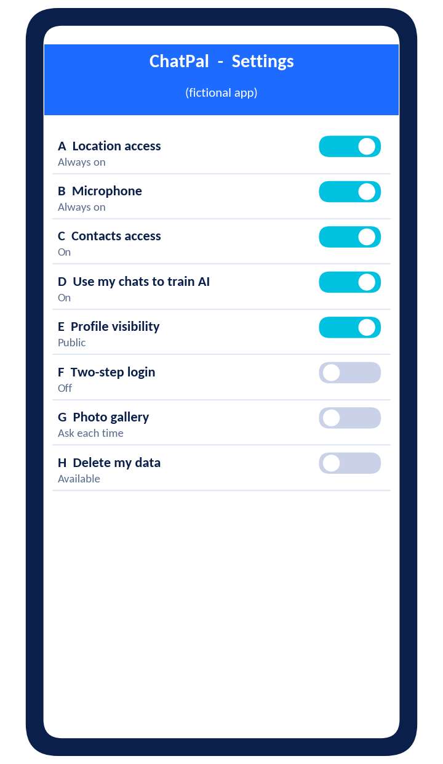
  Setting | Risk | What I would change
  A
  B
  C
  D
  E
  F
  G
  H

Activity B: Spot the oversharing
READ THE POST
Fictional social post by "Tara":
"Just got my new school ID! Here's me outside my house (No. 14, Lotus Lane) before leaving for Greenfield Public School at 7:30 every day. Mum and Dad are away this weekend, so I'm home alone with my brother!"
List at least five privacy risks in this post and how Tara could post the same happy news more safely.

Activity C: Scenario cards
Fictional scenario | Main risk | Safer action
Pasting a classmate's phone number into a chatbot to "format the list".
A free app asks you to upload 20 selfies to "train" a face filter.
A smart speaker with an always-on mic sits in your bedroom.
A photo-aging app asks for access to all your photos and contacts.
Logging in to your email on free public Wi-Fi at the mall.

REFLECT
Reflection: Which risk worried you most, and which of your own settings will you check tonight?



PART 3
Responsible AI in Action
From knowing to doing: roles, cases, debate and projects.
3.1 Who Is Responsible? Roles in Responsible AI
3.2 Using AI Fairly, Safely and Responsibly Every Day
3.3 Case Studies
3.4 Group Discussion and Debate
3.5 Mini-Project: Responsible AI Safety Guide for Students
3.6 My Personal Responsible-AI Checklist

3.1 | Who Is Responsible? Roles in Responsible AI  Responsible AI in Action | Students, developers, organisations and governments

Responsible AI is a team effort. No single person or group can make AI fair, safe and private alone. Each group has its own job, and they check one another.
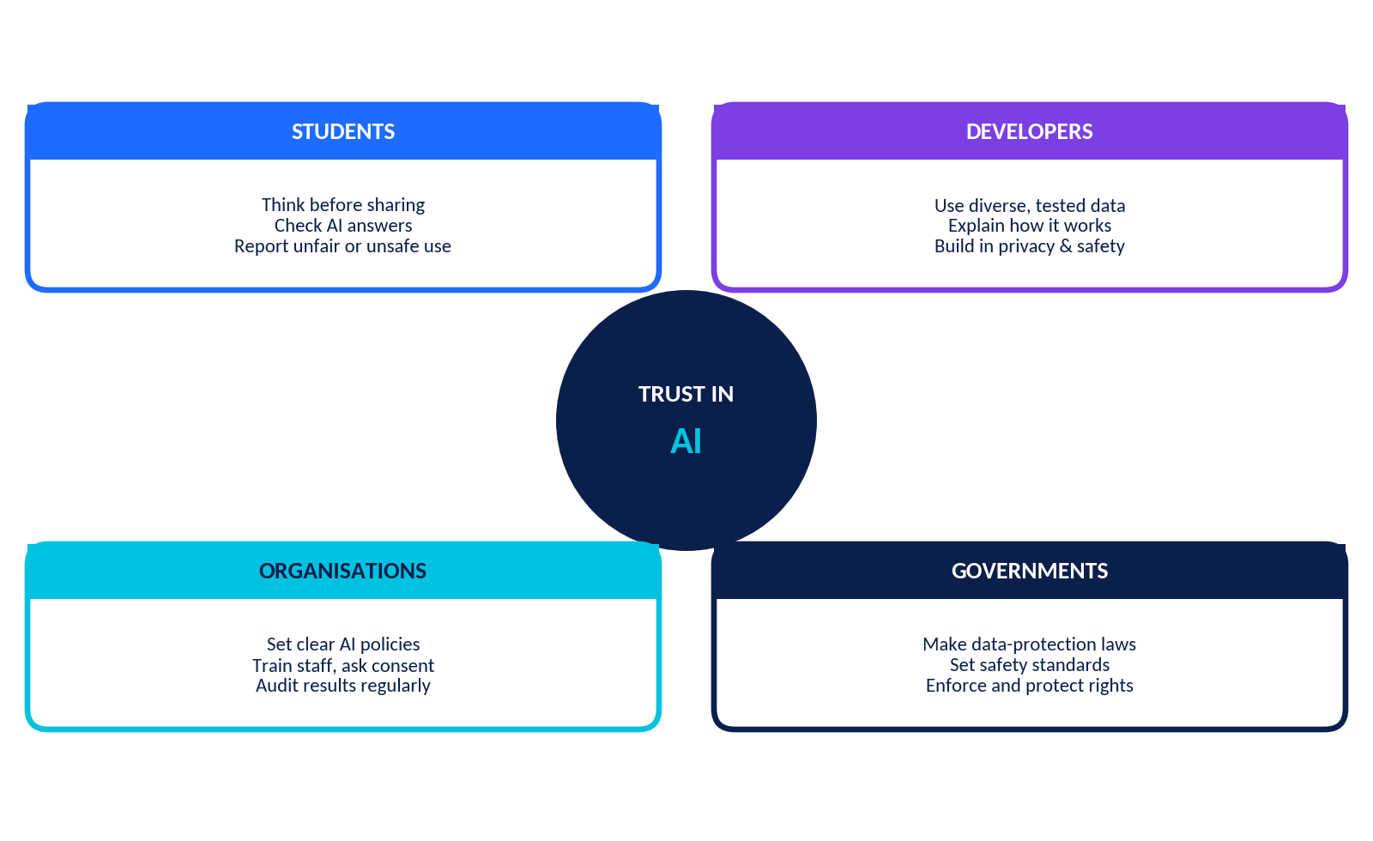
Figure 3.1: Four groups share the responsibility for trustworthy AI.
Group | Key responsibilities | Example in action
Students | • Think before sharing data  • Check AI answers with reliable sources  • Be honest about AI help in schoolwork  • Report unfair, unsafe or fake content | Riya checks a chatbot's history fact in her textbook and tells her teacher she used AI for brainstorming.
Developers | • Use diverse, well-checked data  • Test results for every group  • Explain limits clearly  • Build privacy and safety into the design | A team tests a voice app with many accents before launch and publishes known limits.
Organisations (schools, companies, hospitals) | • Set clear AI policies  • Train staff and ask for consent  • Keep humans in charge of key decisions  • Audit results and handle complaints | A school requires teacher review of AI-flagged exam cases and offers an appeal.
Governments and regulators | • Make data-protection and safety rules  • Set standards for high-risk uses  • Enforce rules and protect rights  • Support education and research | A law lets people ask companies to delete their personal data.

KEY IDEA
Good outcomes need all four: informed users, careful developers, responsible organisations and sensible laws. If one group fails, the others must catch the problem.

THINK AND WRITE
Which of the four groups do you think has the hardest job? Which group is you now, and which might you be in the future?

IN A NUTSHELL
Students, developers, organisations and governments each have a role. Responsible AI works when they share information and hold one another accountable.

3.2 | Using AI Fairly, Safely and Responsibly Every Day  Responsible AI in Action | The CHECK habit

You do not need special equipment to practise Responsible AI. You need a few habits. Use the CHECK routine before you trust or share anything with an AI tool.
Letter | Habit | In practice
C | Consider what you share | Use sample data; keep passwords, OTPs, addresses and private photos out of chats.
H | Handle answers with a critical eye | AI can be wrong or invent facts. Verify important claims with books, teachers or trusted sites.
E | Ensure fairness | Watch for stereotypes in AI text or images. Do not use AI to judge or label people.
C | Credit and honesty | Follow school rules, say when AI helped you and never pass off AI work as only yours.
K | Keep control | Check settings, say no to unnecessary permissions and make final decisions yourself.

Everyday situations
Where | Responsible use | Be careful about
Homework and study | Ask AI to explain concepts, quiz you or give feedback on your own draft. | Copying answers without understanding, or trusting facts without checking.
Social media and photos | Check who can see your posts; ask permission before posting friends. | Posting locations or routines; AI-edited images that mislead others.
Shopping and recommendations | Compare prices and reviews on more than one site. | Letting a feed narrow your choices; sharing payment details.
Health and wellness apps | Use them for general information and reminders. | Self-diagnosis; always ask a doctor for medical decisions.
Gaming and chat | Use nicknames; mute and report abuse. | Sharing real names, school and location with strangers.

KEEPING BALANCE
AI is a powerful assistant. Used with care, it saves time, helps you learn and opens new ideas. The aim of these habits is confidence, not fear. A confident user asks, "What does this tool do with my data, and can I trust this answer?"

MY TIP
Choose one situation from the table. Write a short, two-sentence tip you would give to a younger student.

IN A NUTSHELL
CHECK before you trust: Consider what you share, Handle answers critically, Ensure fairness, Credit honestly, Keep control.

3.3 | Case Studies  Responsible AI in Action | Two fictional cases, two sets of decisions

Case Study 1: BrightPath Admissions AI (fairness)
This case is fictional.
BrightPath Tech College uses an AI to shortlist applicants for its robotics programme. The AI was trained on ten years of past admissions, in which 85% of admitted students came from three city schools. Its inputs include school ranking, number of clubs, pin code and a video-interview score based on facial expressions. The shortlist rates were: city schools 55%, other urban schools 30%, rural schools 12%. The college says, "The AI is objective." Kabir, a rural student with top marks and a state robotics prize, was not shortlisted.
- Identify one example each of data bias, design bias and decision bias in this case. (3)
- Name two features that may act as proxies and explain why. (2)
- Calculate the ratio of the rural shortlist rate to the city shortlist rate. Is it below the 80% warning level? (2)
- Who should be accountable for this system? Give two reasons. (2)
- Suggest three changes BrightPath should make before using the AI again. (3)
- Should BrightPath use AI at all? Give a balanced answer in 3-4 lines. (3)

Case Study 2: EchoBuddy in the Classroom (privacy)
This case is fictional.
Lakeview School installs "EchoBuddy" smart speakers in classrooms to give pronunciation practice. EchoBuddy records student voices, stores recordings for two years "to improve the service" and shares them with a partner company. Parents received a one-line notice with no opt-out. During a break, a speaker accidentally recorded a private conversation about a student's health. Later, a security fault exposed about 2,000 recordings.
- List the types of personal and sensitive data involved. (2)
- Which principles were broken: consent, minimisation, storage limitation or security? Explain each briefly. (4)
- Who is responsible for fixing this: the school, the company or both? Justify. (2)
- Write four rules for a better "EchoBuddy Policy" at Lakeview. (4)
- What can students do to protect themselves around always-listening devices? (2)
- Describe one real benefit of EchoBuddy that the school might wish to keep, and how to keep it safely. (2)

3.4 | Group Discussion and Debate  Responsible AI in Action | Argue with evidence, listen with respect

DEBATE MOTION
Motion: "AI systems that make important decisions about people, such as admissions, hiring or loans, should always have a human make the final decision."

Step | Time | What happens
1. Preparation | 8 min | Teams (Proposition and Opposition) plan arguments. Judges read the scoring sheet.
2. Opening statements | 2 min each | Each side states its main claims.
3. Rebuttal | 2 min each | Each side answers the other's claims with evidence.
4. Open floor | 5 min | Questions from the audience.
5. Closing statements | 1 min each | Summarise and give your strongest point.
6. Judges' feedback | 3 min | Judges give marks and one suggestion for each team.

Argument starter bank
Proposition (for) | Opposition (against)
• Humans can understand context, such as a student's special circumstances.  • A person can be held accountable and explain a decision.  • It can catch AI errors and bias before they harm people. | • Humans can be biased and inconsistent too; AI can be more consistent.  • Human review is slow and costly, so fewer people may be served.  • People may simply approve whatever AI suggests (automation bias).
Tip: a strong argument has a claim, a reason and an example. Before you speak, ask "Who is affected?" and "What evidence do I have?"

Judges' scoring sheet
Criteria | Max | Proposition | Opposition
Clear, relevant arguments | 5
Use of evidence and examples | 5
Rebuttal and listening | 5
Respect, teamwork and time-keeping | 5
Total | 20
Judges' comment (one strength and one improvement for each team):

REFLECTION
After the debate: Did your opinion change? Which argument from the other side was the most convincing? Write a 3-line reflection.

3.5 | Mini-Project: Responsible AI Safety Guide for Students  Responsible AI in Action | Create something other students will use

Your mission: create a clear, attractive Responsible AI Safety Guide for Students that teaches Grade 9 to 12 students how to use AI tools fairly, safely and privately. Work alone or in teams of three or four. Use fictional examples only. Do not include real passwords, photos, addresses or any sensitive information.

Choose a format
A folded A4 leaflet, a six-page booklet, a poster set, a slide deck of 8 to 10 slides, or a one-page infographic with a short audio explanation.

Required content (at least eight panels)
Panel | Must include
1. Welcome | What is Responsible AI and why it matters in one short paragraph.
2. Fairness and bias | Meaning of fairness and bias; one real or fictional example.
3. Spot the bias | Three questions students can ask about an AI result.
4. Privacy basics | Personal vs sensitive data; digital footprint.
5. Safe prompts | A do and don't list, with the traffic-light idea.
6. Passwords and security | Strong passphrases, two-factor authentication, phishing signs.
7. Check your settings | Five privacy settings to review.
8. If something goes wrong | Steps to take and who to tell.

Planning grid
Panel | Key message (one line) | Visual idea | Done
1
2
3
4
5
6

Steps
- Plan: share the work, choose a format and a title.
- Research: use this workbook and one reliable source. Note its name.
- Draft: write short, friendly sentences for Grade 9 students.
- Design: use the colours navy, electric blue, cyan, violet and white, and add one original diagram.
- Test: ask a classmate to read it. Can they explain every panel?
- Present: share in two minutes. Explain one choice you made.

Marking rubric (20 marks)
Criteria | Excellent (4) | Good (3) | Developing (1-2)
Accuracy of content | All ideas correct and clear | Mostly correct | Several errors
Coverage of required panels | All eight, with examples | 6-7 panels | Fewer than 6
Student-friendly language | Clear, short and engaging | Mostly clear | Hard to follow
Design and visuals | Neat, consistent, meaningful visuals | Good with minor issues | Cluttered or plain
Responsible practice | Only fictional or generic data; sources named | Minor slip | Shares sensitive details

3.6 | My Personal Responsible-AI Checklist  Responsible AI in Action | Tick, track, improve

Use this checklist for one month. Tick a box when you do it consistently. Review it with a friend or teacher.
Before I use an AI tool | ✓
☐ I know what the tool is for and whether my school allows it.
☐ I have checked its privacy settings, including chat history and training options.
☐ I will use sample or generic details instead of my real information.
☐ I have not included passwords, OTPs, private photos, addresses or confidential files.

While I use it | ✓
☐ I treat answers as a starting point and verify important facts.
☐ I look for stereotypes or unfair statements and question them.
☐ I use AI to learn, not to copy, and I keep my own thinking.
☐ I stop and ask a trusted adult if something feels unsafe or strange.

After I use it | ✓
☐ I delete sensitive chats or files I no longer need.
☐ I log out on shared devices.
☐ I give credit when AI helped with my work.
☐ I report fake, harmful or unfair content.

My everyday habits | ✓
☐ I use strong, different passwords and two-factor authentication.
☐ I review app permissions every month.
☐ I ask permission before sharing photos or information about others.
☐ I help a friend or family member with one safety setting.

30-day tracker
Week |  | Habits I kept | One thing to improve
Week 1
Week 2
Week 3
Week 4
MY PLEDGE
My pledge: I will use AI fairly, protect my privacy and the privacy of others, think for myself and speak up when something is not right.
Name: ____________________ Signature: ____________________ Date: ____________

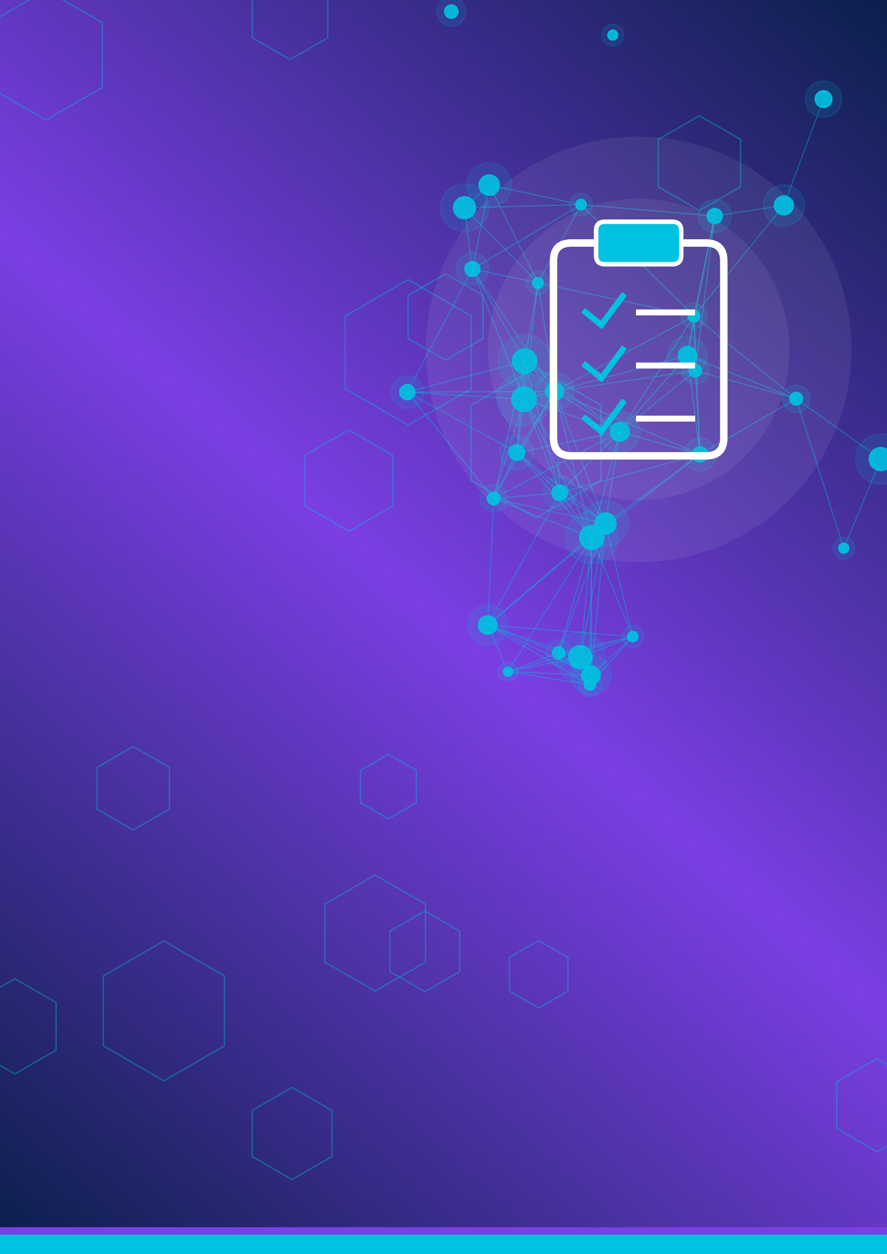

PART 4
Practice and Assessment
Activities, puzzles, worksheets, revision and a 30-mark test.
4.1 Classroom Activities
4.2 Puzzles and Challenges
4.3 Three Worksheets
4.4 MCQ Challenge Round
4.5 Unit Summary and Concept Map
4.6 Revision Questions 4.7 Glossary
4.8 Unit 6 Assessment 4.9 Answer Key

4.1 | Classroom Activities  Practice & Assessment | Five hands-on activities on fairness, bias, privacy and ethics

Activity 1: Fair or Unfair? Human Sorting Game
Focus: AI fairness | Time: 15 minutes | Materials: Three signs: FAIR, UNFAIR, DEPENDS
Your teacher reads a scenario. Move to a sign and be ready to explain. Record your group's decisions after the game.
# | Scenario (fictional) | Our decision | Reason
1 | A music app recommends songs based on your listening history.
2 | A bank AI offers lower loan limits to people from one neighbourhood who have the same income as others.
3 | A reading app gives extra practice to students with the lowest reading scores.
4 | A hiring AI automatically rejects résumés with career gaps, with no human check.
5 | An essay grader gives lower scores to a regional writing style.
6 | A scholarship AI gives bonus points to students from under-resourced schools.

Activity 2: The Biased Intern: A Human AI Experiment
Focus: Bias in data | Time: 25 minutes | Materials: This page, calculator
Your group is the "AI". Study the past hires table, write a shortlisting rule using only this data, then apply it to six new candidates.
Past hires (fictional) | College | Hobby
H1, H2, H3, H4, H5, H6, H7, H8 | Hillview Institute | Chess (6), Robotics (2)
H9 | Lakeside College | Music
H10 | Riverdale College | Football

New candidate | College | Hobby | Marks
N1 Aarav | Hillview Institute | Chess | 62%
N2 Bela | Lakeside College | Robotics champion | 94%
N3 Chirag | Riverdale College | Music | 88%
N4 Dia | Hillview Institute | Football | 70%
N5 Esha | Lakeside College | Chess | 90%
N6 Farid | Riverdale College | Robotics | 81%
Our rule: ______________________________________________ Candidates shortlisted: ______________
Reflection: Whom did the rule favour? Who was missed? What data would make the "AI" fairer?

Activity 3: Privacy Detectives: The Digital Footprint Trail
Focus: Privacy and data combining | Time: 20 minutes | Materials: This page
"Zara" is a fictional student. Read her public clues and decide what a stranger could work out by combining them.
- Photo wearing a Greenfield Public School blazer.
- Post: "Football practice every Tuesday and Thursday at 5 pm, Riverside Ground."
- Tagged birthday photo: "Zara's 16th! Born on 3 March."
- Comment: "Our flat in Maple Court has no Wi-Fi again!"
- Story with a location tag at "Sunrise Café", near Maple Court.
- The same username "zara_gps_2009" on every app.
What can a stranger work out? | How can Zara reduce the risk?

Activity 4: The Consent Role-Play
Focus: Consent and responsible data use | Time: 20 minutes | Materials: Role cards, consent checklist
Fictional app FriendFinder AI wants access to contacts, microphone and location. Roles: App Developer, Student, Parent/Guardian, Privacy Officer. Run a 5-minute conversation. Then score the app's request.
Consent test | Yes / No | Evidence from the role-play
Freely given (can say no)?
Informed (clear explanation)?
Specific (clear purpose)?
Easy to withdraw?

Activity 5: Four Corners: The Hospital Triage Dilemma
Focus: Ethical decisions | Time: 25 minutes | Materials: Corner signs: Strongly Agree, Agree, Disagree, Strongly Disagree
Fictional "CareFirst AI" suggests the order in which patients are seen in a clinic. It scores people lower if they have missed appointments before. Your teacher reads each statement. Move to a corner, defend your choice, then use STOP in groups.
Statement | My corner | My reason
S1: AI may recommend the order, but a nurse must decide.
S2: Past missed appointments are a fair input for priority.
S3: Patients must be told when AI is involved.
S4: If AI is more accurate than doctors on average, we should always follow it.

4.2 | Puzzles and Challenges  Practice & Assessment | Four brain-teasers on Responsible AI

Puzzle 1: Word Search - Responsible AI Words
Find the 12 hidden words. They run across, down or diagonally (never backwards). Write the row and column of the first letter in the table if you like.
 | 1 | 2 | 3 | 4 | 5 | 6 | 7 | 8 | 9 | 10 | 11 | 12 | 13 | 14
1 | L | B | O | W | K | K | L | J | G | O | K | Q | E | L
2 | V | Y | F | V | E | K | P | A | S | S | W | O | R | D
3 | E | Z | O | T | E | N | W | A | U | D | I | T | I | Q
4 | M | A | O | L | R | R | C | S | T | S | I | Z | J | J
5 | I | D | T | P | M | A | S | R | W | T | S | I | B | K
6 | K | I | P | N | F | T | N | I | Y | C | M | G | P | S
7 | W | C | R | H | A | J | B | S | G | P | C | F | H | A
8 | C | O | I | T | I | W | C | Y | P | H | T | Y | I | F
9 | B | N | N | K | R | B | E | B | R | A | T | T | S | E
10 | S | S | T | T | N | C | Z | I | I | H | R | A | H | T
11 | M | E | T | Y | E | P | M | A | V | W | K | E | I | Y
12 | T | N | K | X | S | O | J | S | A | C | Q | X | N | K
13 | N | T | X | J | S | B | V | J | C | D | A | K | G | T
14 | A | S | F | W | V | Y | T | H | Y | J | T | P | U | I

☐ FAIRNESS | ☐ PRIVACY | ☐ CONSENT
☐ FOOTPRINT | ☐ OVERSIGHT | ☐ BIAS
☐ SAFETY | ☐ PASSWORD | ☐ PHISHING
☐ AUDIT | ☐ TRANSPARENT | ☐ ENCRYPT

Puzzle 2: Cipher Decoder - Secret Safety Rules
Each message below was hidden by moving every letter 3 places forward in the alphabet (A becomes D, B becomes E, and so on). Move each letter 3 places back to reveal a safety rule.
Plain | A | B | C | D | E | F | G | H | I | J | K | L | M
Cipher | D | E | F | G | H | I | J | K | L | M | N | O | P

Plain | N | O | P | Q | R | S | T | U | V | W | X | Y | Z
Cipher | Q | R | S | T | U | V | W | X | Y | Z | A | B | C
Message 1: QHYHU VKDUH BRXU SDVVZRUG

Message 2: FKHFN WKH SULYDFB VHWWLQJV

Message 3: DVN EHIRUH BRX SRVW D SKRWR

Puzzle 3: Logic Puzzle - Who Overshared What?
Four fictional friends Asha, Bilal, Chen and Divya each overshared one different item: a password, a home address, an OTP code or a private photo. Use the clues to find who shared what.
- Asha did not share the password or the OTP code.
- Bilal did not share the private photo or the home address.
- Chen did not share the OTP code.
- Divya did not share the home address or the password.
- The home address was not shared by Asha.
 | Password | Home address | OTP code | Private photo
Asha
Bilal
Chen
Divya
Bonus: for each friend, write one safe action they could have taken instead.

Puzzle 4: Unscramble and Riddle
Unscramble each key word using the clue.
Scrambled | Clue | Your answer
YACRVPI | Your right to control your information
TSNENOC | Free, informed permission
RSEANFSI | Treating people equitably
IHPHSING | A trick message that steals information
TDIUA | A systematic check, such as of fairness
IOOFTNTPR | The trail you leave online
EHTIOSGVR | People watching over AI decisions
OPRDSSWA | A secret you must never share
Riddle: "I get larger every time you post, search or click, but I am only partly visible. Some of me you create on purpose, the rest is collected quietly. What am I?" ______________________

WS1 | Worksheet 1: Fairness and Bias  Chapters 1.1 to 1.6 | 12 questions | Total: 14 marks

Name: _________________________ Class: ________ Date: ____________ Score: ______ / 14
1. Which statement best describes bias in AI? [1 mark]
(A) A deliberate plan to harm users | (B) A systematic pattern that produces unfair results for some people or groups
(C) A random error that happens only once | (D) A hardware fault in the computer
2. A hiring AI is trained only on résumés of people hired in the last ten years, most of whom came from one college. This is mainly an example of: [1 mark]
(A) Historical data bias | (B) Hardware failure
(C) Strong cybersecurity | (D) Human oversight
3. In a fictional scholarship AI, which input is most likely to act as a proxy for family income? [1 mark]
(A) Marks in Mathematics | (B) Home pin code
(C) Attendance percentage | (D) Number of essays submitted
4. Human oversight in AI means that: [1 mark]
(A) AI works without any human involvement | (B) People can monitor, question and override AI decisions
(C) Only developers may see the results | (D) AI replaces all teachers
5. An AI is 95% accurate overall but only 70% accurate for one group. The best next step is to: [1 mark]
(A) Release it because overall accuracy is high | (B) Ignore that group
(C) Investigate and fix the gap before wider use | (D) Delete all data about that group
6. The principle that a clear person or organisation must answer for what an AI does is called ______________. [1 mark]
7. A feature that secretly stands in for something else, such as pin code standing in for income, is called a ______________. [1 mark]
8. When an AI's output changes the data it will learn from next, creating a self-reinforcing cycle, it is called a feedback ______________. [1 mark]
9. Removing the "gender" column from a dataset always removes gender bias. True / False [1 mark]
10. A fair AI must treat every person in exactly the same way, whatever their needs. True / False [1 mark]
11. Explain the difference between equal and equitable treatment using a school example. [2 marks]

12. List three questions a developer should ask to check whether training data is fair. [2 marks]

WS2 | Worksheet 2: Privacy and Data Safety  Chapters 2.1 to 2.8 | 12 questions | Total: 18 marks

Name: _________________________ Class: ________ Date: ____________ Score: ______ / 18
1. Which of these is sensitive personal information? [1 mark]
(A) A favourite colour | (B) Fingerprint or face-scan data
(C) The name of a public park | (D) The title of a film you like
2. Location history collected by your phone in the background is part of your: [1 mark]
(A) Active footprint | (B) Passive footprint
(C) Public footprint | (D) Encrypted footprint
3. A chatbot claiming to be from your bank asks you to type the OTP you just received. You should: [1 mark]
(A) Type it quickly | (B) Type only half of it
(C) Never share it, and contact the bank through its official channel | (D) Post it online and ask for advice
4. Data minimisation means: [1 mark]
(A) Collecting as much data as possible | (B) Collecting only the data needed for a clear purpose
(C) Making data files smaller | (D) Deleting all data every day
5. Which of these is the strongest passphrase (fictional example)? [1 mark]
(A) password123 | (B) Riya2008
(C) Green-Comet-Rides-9-Bridges! | (D) qwerty
6. Match each term in Column A with its meaning in Column B. [5 marks]
Column A | Answer | Column B
1. Consent |  | (a) Scrambling data so that only authorised people can read it
2. Encryption |  | (b) Removing or hiding identifying details from data
3. Phishing |  | (c) A fake message that tricks you into revealing information
4. Anonymisation |  | (d) A document explaining how an organisation handles your data
5. Privacy policy |  | (e) Your free, informed agreement to data being used for a stated purpose
7. The trail of data you leave online is called your digital ______________. [1 mark]
8. Logging in with a password plus a one-time code is called two-factor ______________. [1 mark]
9. If an AI chatbot is free, it is always safe to type personal documents into it. True / False [1 mark]
10. A privacy policy can usually tell you what data an app collects and how long it keeps it. True / False [1 mark]
11. Name three things you should never share with an AI chatbot and explain why for one of them. [2 marks]

12. Give one benefit and one limitation of using AI to detect phishing emails. [2 marks]

WS3 | Worksheet 3: Responsible AI in Practice  Mixed topics and applications | 12 questions | Total: 19 marks

Name: _________________________ Class: ________ Date: ____________ Score: ______ / 19
1. A school's AI tool flags students for cheating, but flags more students with slower home internet. The most responsible first step is to: [1 mark]
(A) Trust the tool because it is automated | (B) Have people review the flagged cases and test for the pattern before using the results
(C) Punish all flagged students | (D) Hide the results from students
2. Which action by a government best supports Responsible AI? [1 mark]
(A) Passing and enforcing data-protection laws | (B) Banning all AI tools
(C) Collecting everyone's data for itself | (D) Leaving every decision to companies
3. A smart-speaker company says, "We may keep recordings to improve our service." Which question should a careful user ask? [1 mark]
(A) How many colours does it come in? | (B) How long are recordings kept and can I delete them?
(C) Is it cheaper on Mondays? | (D) Does it have a loud speaker?
4. Which is the best example of transparency? [1 mark]
(A) An app labels a summary "generated by AI" and explains what data it used | (B) An AI hides how it makes decisions
(C) Developers keep their test results secret | (D) AI and human writing are mixed with no labels
5. Match each action to the group most responsible for it. [4 marks]
Column A | Answer | Column B
1. Runs bias tests across groups before release |  | (a) Students
2. Passes laws on data protection and sets penalties |  | (b) Developers
3. Checks an AI answer in a textbook and keeps passwords private |  | (c) Organisations
4. Requires human review of AI hiring shortlists in its policy |  | (d) Governments
6. The percentage of applicants selected from a group is called the selection ______________. [1 mark]
7. A rule of thumb used in some hiring audits says to look closer if a group's selection rate is below ______ % of the highest group's rate. [1 mark]
8. AI can help protect privacy, but it cannot guarantee complete security. True / False [1 mark]
9. Responsible AI means avoiding all AI tools. True / False [1 mark]
10. In a fictional hospital app test, Group P: 250 people tested, 10 cases missed. Group Q: 150 people tested, 21 cases missed. Calculate the miss rate (%) for each group and state which group is served less well. [3 marks]

11. Describe two ways a student can use AI for homework responsibly. [2 marks]

12. Give two reasons it is risky to rely on an AI answer for a health decision without a human check. [2 marks]

4.4 | MCQ Challenge Round  Practice & Assessment | 12 extra multiple-choice questions | 12 marks

Choose the best answer. Write your choices in the answer grid at the end.
1. Which situation best shows a lack of transparency?
(A) A student is refused a place by an AI and no one can explain the reasons | (B) A school publishes how its AI tutor works
(C) A company lists the data its app collects | (D) A teacher checks an AI-graded essay
2. A "human-in-the-loop" design means that:
(A) The AI trains itself with no checks | (B) A person reviews or approves important AI outputs
(C) Humans only repair the hardware | (D) The AI works only at night
3. Why is biometric data such as a face scan treated with extra care?
(A) It is always public | (B) It cannot be changed like a password if it is leaked
(C) It is very small in size | (D) It is never used by AI
4. A sign-up form has "Yes, share my data with partners" already ticked. This is an example of:
(A) Informed consent | (B) A dark pattern
(C) Encryption | (D) Data minimisation
5. You find a realistic AI-generated image of a classmate that is clearly fake and embarrassing. The best action is to:
(A) Share it with friends for a laugh | (B) Do not share it; keep evidence, report it and tell a trusted adult
(C) Edit it to make it funnier | (D) Ignore it and delete your account
6. In federated learning, the model:
(A) Collects all raw data onto one server | (B) Learns on users' devices and shares only small updates
(C) Never learns anything | (D) Deletes the users' devices
7. Differential privacy protects people mainly by:
(A) Adding small random noise so individuals cannot be singled out | (B) Making all passwords identical
(C) Blocking all websites | (D) Making photos larger
8. The idea that data should be kept only as long as it is needed is called:
(A) Storage limitation | (B) Data hoarding
(C) Label bias | (D) Over-fitting
9. Which action is least likely to reduce bias in a model?
(A) Collecting more data from under-represented groups | (B) Testing separately for each group
(C) Adding more of the same majority-group data only | (D) Reviewing close cases by humans
10. An AI study helper gives a wrong medicine dose. Which design feature would most help prevent harm?
(A) A brighter colour scheme | (B) Clear limits, safe-use warnings and a referral to a qualified professional
(C) Faster typing speed | (D) More emojis in answers
11. Which is the safest practice on public Wi-Fi?
(A) Log in to bank accounts as usual | (B) Avoid sensitive logins, or use a trusted secure connection
(C) Share the Wi-Fi password with strangers | (D) Turn off all updates
12. Which line in a privacy policy is the clearest warning sign?
(A) "We delete chat history after 90 days on request." | (B) "We collect only your nickname and class."
(C) "We may share your data with any third party for any purpose." | (D) "You can switch off model training in Settings."

Q | 1 | 2 | 3 | 4 | 5 | 6 | 7 | 8 | 9 | 10 | 11 | 12
Ans

4.5 | Unit Summary and Concept Map  Practice & Assessment | Everything on one page

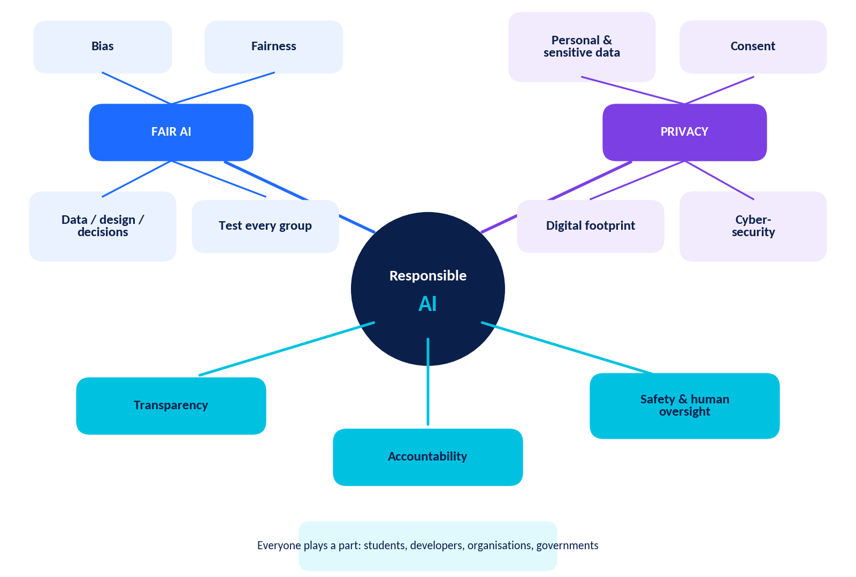
Figure 4.1: Concept map of Unit 6 - Responsible AI.
Topic | Key takeaways
Fair AI Challenge | • Responsible AI is fair, transparent, accountable, safe, privacy-respecting and under human oversight.  • Bias enters through data, design and decisions. Proxies and feedback loops are common causes.  • Identify bias by comparing groups, reduce it with better data and design, and prevent it with teams, checklists, monitoring and appeals.
Privacy in an AI World | • Personal, sensitive and confidential data need different levels of care. Your digital footprint has an active and a passive part.  • AI collects data directly, by observing and by inferring. Check each step of the data journey.  • Share smartly, use settings and policies, give real consent, and use strong passwords with two-factor authentication.
Responsible AI in action | • Students, developers, organisations and governments share responsibility.  • Use the CHECK habit: Consider, Handle, Ensure, Credit, Keep control.  • No AI is completely fair or secure, so keep testing, learning and staying in control.

4.6 | Revision Questions  Practice & Assessment | 12 open questions for self-study

Answer in your own words. Suggested answers are in the Answer Key.
1. Define Responsible AI in your own words and give one reason it matters in healthcare.

2. Describe how a feedback loop could make a recommendation app treat a new creator unfairly.

3. Why can "more data" fail to fix bias?

4. Give one example each of personal, sensitive and confidential information (fictional).

5. Explain the difference between an active and a passive digital footprint with one smartphone example of each.

6. List four things to look for in a privacy policy.

7. Why are biometric identifiers more sensitive than passwords?

8. Explain how federated learning or differential privacy helps protect privacy.

9. Write a three-step plan for what to do if you accidentally shared private information with an AI chatbot.

10. In one line each, describe the role of students, developers, organisations and governments in Responsible AI.

11. Why is human oversight important when AI makes high-stakes decisions?

12. Write a balanced statement about AI that avoids both "AI is always right" and "AI cannot be trusted at all".

4.7 | Glossary  Practice & Assessment | 30 key terms

Term | Meaning
Accountability | Having a named person or organisation responsible for an AI system's actions and for fixing harm.
Algorithm | A set of step-by-step instructions a computer follows.
Anonymisation | Removing or hiding details that identify a person in data.
Automation bias | Trusting a computer's answer without enough checking.
Bias (AI) | A systematic pattern that produces unfair results for some people or groups.
Biometric data | Data about body features, such as face, fingerprint or voice, used to identify people.
Consent | Free, informed, specific and withdrawable agreement to use your data.
Cybersecurity | Practices and tools that protect devices, accounts and data from attack.
Data minimisation | Collecting and keeping only the data that is needed.
Data protection | Rules and technical steps that keep personal data safe and lawfully used.
Deepfake | Realistic fake image, audio or video created by AI.
Differential privacy | Adding small random noise to results so individuals cannot be singled out.
Digital footprint | The trail of data you leave online, both active and passive.
Encryption | Scrambling data so only authorised people can read it.
Fairness | Treating people and groups equitably, without unjustified disadvantage.
Federated learning | Training a model on users' devices, sharing only small updates instead of raw data.
Feedback loop | When an AI's output changes the data it later learns from, reinforcing a pattern.
Human oversight | People being able to monitor, question and override AI decisions.
Inferred data | Information AI guesses about you from patterns, not given directly.
Model | The pattern-finding system created when an AI learns from data.
Personal information | Any information that can identify you directly or in combination.
Phishing | A fake message designed to trick you into revealing information or clicking a harmful link.
Privacy policy | A document explaining how an organisation collects, uses and shares data.
Proxy | A feature that stands in for something else, such as pin code for income.
Responsible AI | Designing and using AI to be fair, safe, transparent, accountable and respectful of rights.
Selection rate | The percentage of applicants from a group who are selected.
Sensitive information | Data that could cause serious harm or unfair treatment if exposed.
Training data | The examples an AI learns from.
Transparency | Being open about when and how AI is used and how decisions are reached.
Two-factor authentication | Logging in with two checks, such as a password and a one-time code.

4.8 | Unit 6 Assessment  Responsible AI | Time: 45 minutes | Maximum marks: 30

Name: _________________________ Class: ________ Date: ____________ Score: ______ / 30
INSTRUCTIONS
Answer all questions. Use fictional or sample details only. Marks are shown in brackets.

Section A: Multiple choice (8 × 1 = 8 marks)
1. Which of the following is not a main way in which bias can enter an AI system? [1]
(A) Data | (B) Design
(C) Decisions | (D) Screen brightness of the monitor
2. A chatbot app asks a student to upload a photo of their ID card to "get started". The best response is to: [1]
(A) Upload it immediately | (B) Check why it is needed, avoid uploading, and ask a trusted adult or use the official channel
(C) Upload a friend's ID instead | (D) Post the ID online to ask for advice
3. In a school AI attendance system, accountability means: [1]
(A) The software cannot be changed | (B) A named person or team is responsible for reviewing errors and handling complaints
(C) Only students are responsible for mistakes | (D) The system has a colourful display
4. Which action adds to your active digital footprint? [1]
(A) A website storing cookies in the background | (B) Your phone recording your location
(C) Posting a comment under a video | (D) An app noting your device type
5. Which statement about AI fairness is most accurate? [1]
(A) A good AI is always completely fair | (B) No AI can be guaranteed completely fair, so testing and monitoring must continue
(C) Fairness only matters in banks | (D) Fairness is checked once before release and never again
6. A shop uses cameras to scan every visitor's face without telling them. The main concern is: [1]
(A) Consent and privacy | (B) The price of cameras
(C) The colour of the shop | (D) The speed of the internet
7. Two-step verification helps because: [1]
(A) It makes passwords unnecessary | (B) Even if a password is stolen, the attacker still needs the second step
(C) It deletes your account | (D) It stops all phishing emails automatically
8. Which is the best example of data minimisation? [1]
(A) A quiz app asks for a nickname and grade only | (B) A quiz app asks for your home address and ID number
(C) A quiz app records your microphone all day | (D) A quiz app keeps your data forever

Section B: Fill in the blanks (4 × 1 = 4 marks)
9. Comparing an AI's results across different groups to look for unfair differences is called a fairness ______________. [1]
10. Information that can identify a person, such as a name or phone number, is called ______________ information. [1]
11. AI-generated fake images, audio or video of real people are called ______________. [1]
12. Keeping data only as long as it is needed is the principle of ______________ limitation. [1]

Section C: Match the following (4 × 1 = 4 marks)
13. Match each bias idea in Column A with its example in Column B. (Write the answer for each in the box.) [4]
Column A | Answer | Column B
1. Representation bias |  | (a) More patrols lead to more recorded incidents, which leads to more patrols
2. Proxy |  | (b) A teacher accepts every AI-suggested grade without checking
3. Feedback loop |  | (c) A voice AI trained mostly on one accent mishears others
4. Automation bias |  | (d) Pin code is used as a stand-in for family income

Section D: Short answers (3 × 2 = 6 marks)
17. Explain why the statement "AI is objective, so it cannot be biased" is misleading. [2]

18. State two privacy settings you would check before using a new AI app and say why. [2]

19. Describe two ways an organisation can show accountability for AI decisions. [2]

Section E: Data analysis (4 marks)
20. A fictional shortlisting app, CareMatch, produced these results. [4]
Group | Applicants | Shortlisted | Selection rate (%)
Group X | 80 | 56
Group Y | 50 | 20
Group Z | 70 | 49
- Calculate the selection rate for each group. (1)
- Calculate the ratio of Group Y's rate to the highest rate, as a percentage. (1)
- Which group is flagged under the 80% rule of thumb, and why? (1)
- Suggest one action the developers should take. (1)

Section F: Scenario (4 marks)
21. A student finds a free AI app that edits photos. It asks for access to the camera, all photos, contacts and microphone, and its policy says data may be shared with partners "for any purpose". [4]
- Identify two risky permissions or policy points. (2)
- Give two pieces of advice to the student. (2)

Marking scheme and grade bands
Section | Questions | Marks | How marks are awarded
A: MCQ | 1-8 | 8 | 1 mark for each correct option.
B: Fill in the blanks | 9-12 | 4 | 1 mark for each correct word. Accept clear spelling variations noted in the key.
C: Match | 13-16 | 4 | 1 mark for each correct pair.
D: Short answers | 17-19 | 6 | 2 marks each: 1 for a correct idea, 1 for explanation or example.
E: Data analysis | 20 | 4 | 1 mark for each part (1)-(4); award follow-through marks for correct method.
F: Scenario | 21 | 4 | 2 marks for two risks (1 each); 2 marks for two pieces of advice (1 each).
Total |  | 30

Score | 27-30 | 22-26 | 16-21 | 10-15 | Below 10
Band | Outstanding | Strong | Secure | Developing | Needs support

4.9 | Answer Key and Suggested Answers  Practice & Assessment | For teachers and self-checking

For open-ended items, accept any reasonable answer that shows understanding. Suggested answers are examples, not the only correct response.

Part 1: Fair AI Challenge
Item | Suggested answer
1.1 Think | Answers vary. Example: a photo-editing app; privacy matters most because it uses my photos.
1.2 Spot the door | a) Data (representation bias) b) Design (proxy feature) c) Decision (automation bias) d) Data (label bias)
1.3 Pillar Detective | Recruitment tool: fairness (also human oversight). UK grading 2020: accountability/human oversight (no easy appeal) and fairness. Hospital risk tool: fairness (proxy measure). ExamGuard AI: fairness and human oversight. Accept well-reasoned alternatives.
1.5 Exercise A | North 48/80 = 60% (ratio 100%, no flag). South 24/60 = 40% (ratio 66.7%, flag). Rural 8/40 = 20% (ratio 33.3%, flag). Hostel 12/20 = 60% (ratio 100%, no flag). Possible reasons: under-representation in past data, location or school type acting as proxy, fewer clubs or resources, travel barriers.
1.5 Exercise B | Group 1: 10/200 = 5%. Group 2: 12/200 = 6%. Group 3: 20/100 = 20%. Group 3 is served least well, 4 times the error rate of Group 1. Actions: add more varied photos of Group 3 (lighting, angles), retest each group, offer a manual check option.
1.5 Exercise C | Fair to use: Marks in Science, Favourite subjects, Attendance %. Proxy/needs care: Home pin code, Parent's job, Phone model, Number of siblings. Sensitive: Gender.
1.5 Exercise D | Sample: (1) Review the data and add more from South and Rural applicants. (2) Remove or adjust proxy inputs and retest selection rates. (3) Add human review of close or flagged cases, monitor monthly and offer appeals.
1.6 Dilemmas | Answers vary. Look for STOP thinking: stakeholders named, harms and benefits weighed, three options, a plan to check. Dilemma 1: use only with human review and alternatives such as a phone check. Dilemma 2: test for language gaps and improve support. Dilemma 3: delay or release with limits and a human check while fixing the gap.

Part 2: Privacy in an AI World
Item | Suggested answer
2.1 Footprint audit | a) A b) P c) P d) A e) P
2.2 Follow the data | Sample: Collect: typed questions, uploaded work. Process: analysis to answer. Store: chat history on servers. Use: improve the model, personalise. Share/delete: partners; deletion on request. Privacy questions: Is this needed? How long kept? Who sees it? Can I delete it?
2.3 Risk rating | Calculator offline: 1. Smart speaker in bedroom: 4-5. Photo-aging app: 4-5. School-approved AI tutor: 2-3 (depends on settings). Reasons should mention amount and sensitivity of data.
2.4 Rewrite challenge | 1: "Help me write a complaint to a landlord about a broken heater. Use [NAME], [ADDRESS]." 2: Never share a password; ask "Why can't I open my online grade portal? It says access denied." 3: Remove the friend's name, marks and health reason: "Help me politely tell my teacher I was absent for a personal reason."
2.5 Consent or not? | 1: No (pre-ticked). 2: Yes (clear, specific). 3: No (not freely given). 4: Yes (clear and optional).
2.6 NovaChat | 1) Collects messages, files, device type, approximate location and usage time; used to provide service, improve AI models and show offers. 2) Partners and advertisers; the description is vague. 3) Good: opt-out of model training, deletion contact, parental permission under 18. Warning: sharing with advertisers, 3-year retention, vague "trusted partners". 4) Settings > Privacy > switch off "Improve our models" and delete chats.
2.8 Activity A | A Location always on: High, set to "while using". B Mic always on: High, allow only when needed. C Contacts: Medium-High, deny. D Chats train AI: Medium, switch off. E Public profile: High, set to friends only. F Two-step login off: High, turn on. G Photos ask each time: Low (good). H Delete my data: Low (good), know how to use it.
2.8 Activity B | Risks: ID card shown; house number and street; school name; daily 7:30 routine; parents away; home alone; mention of brother. Safer: post without ID or address, hide school and routine, share with friends only, post after the event.
2.8 Activity C | 1: Sharing someone else's data; remove or ask permission. 2: Biometric data to unknown app; refuse. 3: Constant listening; unplug or mute and move out of bedroom. 4: Excess permissions; deny or choose another app. 5: Interception on open Wi-Fi; avoid logins or use secure connection.

Part 3: Responsible AI in Action

Case Study 1: BrightPath Admissions AI
1. Data: 85% of past admits from three city schools. Design: pin code or video-interview facial-expression score as inputs. Decision: college treats AI as "objective" and does not review. (3)
2. Pin code and school ranking (location and wealth), number of clubs (resources and opportunity). The facial-expression score may also unfairly disadvantage some students. (2)
3. 12 ÷ 55 = 0.218, about 22%, far below 80%. (2)
4. The college admissions leadership and the developers. They chose, built and deployed the system and can fix and explain it; someone must handle appeals. (2)
5. Any three: retrain on more representative data; remove proxies and the interview score; test selection rates by group; human review of rejected high achievers; publish criteria and offer appeals. (3)
6. Balanced answer: AI can help with large volumes only if tested, fair and overseen by humans; otherwise it should not make decisions. (3)

Case Study 2: EchoBuddy in the Classroom
1. Voice recordings (personal; may identify students), a private conversation about health (sensitive), names and school context. (2)
2. Consent: one-line notice with no opt-out. Minimisation: recorded more than needed, including private talk. Storage limitation: two years is long. Security: 2,000 recordings exposed. (4)
3. Both. The school chose the product and gave poor notice; the company built it, shared data and failed to secure it. (2)
4. Examples: ask clear opt-in consent from parents and students; record only during practice sessions; delete recordings within a short, stated time; no sharing with partners without consent; encrypt and audit; easy deletion requests. (4)
5. Mute or switch off when not needed, avoid private talk near devices, ask about the policy, report accidental recording. (2)
6. Benefit: pronunciation practice. Keep safely by on-device processing, short retention and clear consent. (2)
3.4 Debate, 3.5 Mini-project, 3.6 Checklist: assessed with the rubrics provided. Look for evidence, respectful rebuttal, accurate content and only fictional or generic examples.

Part 4: Activities and Puzzles
Item | Teacher notes and answers
Activity 1 | Suggested: 1 Fair or depends (personalisation is acceptable if transparent). 2 Unfair. 3 Fair (equitable support). 4 Unfair/risky without review. 5 Unfair. 6 Depends: can be fair to correct disadvantage if rules are clear and open. Reasons matter more than labels.
Activity 2 | Expected: the "AI" favours Hillview. Missed: Bela (94%, champion), Esha (90%), Chirag (88%). Fix: use marks and skills, add varied data, test across colleges.
Activity 3 | A stranger can work out: school, age and birth date, routine (Tue/Thu 5 pm), home area (Maple Court), regular café, and can find her on every app by username. Fixes: private accounts, remove tags, avoid routines, unique usernames.
Activity 4 | Look for questions about why contacts and mic are needed, ability to say no, parental involvement, and an app that offers limited permissions.
Activity 5 | S1 usually agree. S2 contested: may disadvantage people with transport or health barriers. S3 agree. S4 usually disagree: averages hide errors for groups, and accountability remains with people.
Puzzle 1 positions (row, column of first letter) | FAIRNESS: row 6, col 5, down; PRIVACY: row 8, col 9, down; CONSENT: row 7, col 2, down; FOOTPRINT: row 2, col 3, down; OVERSIGHT: row 1, col 3, diagonal down-right; BIAS: row 9, col 8, down; SAFETY: row 6, col 14, down; PASSWORD: row 2, col 7, across; PHISHING: row 6, col 13, down; AUDIT: row 3, col 8, across; TRANSPARENT: row 3, col 4, diagonal down-right; ENCRYPT: row 2, col 5, diagonal down-right
Puzzle 2 | Message 1: NEVER SHARE YOUR PASSWORD; Message 2: CHECK THE PRIVACY SETTINGS; Message 3: ASK BEFORE YOU POST A PHOTO
Puzzle 3 | Asha: photo; Bilal: password; Chen: address; Divya: OTP code. (Private photo = Asha, Password = Bilal, Home address = Chen, OTP = Divya.)
Puzzle 4 | PRIVACY, CONSENT, FAIRNESS, PHISHING, AUDIT, FOOTPRINT, OVERSIGHT, PASSWORD. Riddle: digital footprint.

Worksheets, MCQ Round and Revision

Worksheet 1 (total 14 marks)
Q | Answer / suggested answer | Marks
1 | B A systematic pattern that produces unfair results for some people or groups | 1
2 | A Historical data bias | 1
3 | B Home pin code | 1
4 | B People can monitor, question and override AI decisions | 1
5 | C Investigate and fix the gap before wider use | 1
6 | accountability | 1
7 | proxy | 1
8 | loop | 1
9 | False. Other features (proxies) can still carry the same information. | 1
10 | False. Fairness often means equitable treatment: support matched to need, within clear rules. | 1
11 | Equal treatment gives everyone exactly the same thing; equitable treatment gives people what they need to reach a fair result. Example: giving every student the same textbook (equal) versus also giving a large-print copy to a student with weak eyesight (equitable). Award 1 mark for each correct meaning/example. | 2
12 | Any three, such as: Which groups are included and which are missing? Is the data balanced across groups? Were labels made consistently and without stereotypes? Is the data recent and relevant? Could any feature be a proxy? (Award 1 mark for two good questions, 2 marks for three.) | 2

Worksheet 2 (total 18 marks)
Q | Answer / suggested answer | Marks
1 | B Fingerprint or face-scan data | 1
2 | B Passive footprint | 1
3 | C Never share it, and contact the bank through its official channel | 1
4 | B Collecting only the data needed for a clear purpose | 1
5 | C Green-Comet-Rides-9-Bridges! | 1
6 | 1-e, 2-a, 3-c, 4-b, 5-d (Consent; Encryption; Phishing; Anonymisation; Privacy policy) | 5
7 | footprint | 1
8 | authentication (verification also accepted) | 1
9 | False. Free tools may still store or use data; always check settings and avoid sharing personal or confidential files. | 1
10 | True. That is its purpose, although you should look for clear, specific wording. | 1
11 | Any three of: passwords/PINs/OTPs, private photographs, home address, ID or bank numbers, confidential files, other people's personal details. Reason example: a password lets someone take over your account. (1 mark for three items, 1 mark for a correct reason.) | 2
12 | Benefit: can filter huge numbers of messages quickly and block many scams. Limitation: can miss new scams or wrongly block safe emails; attackers also use AI to make convincing messages. (1 mark each.) | 2

Worksheet 3 (total 19 marks)
Q | Answer / suggested answer | Marks
1 | B Have people review the flagged cases and test for the pattern before using the results | 1
2 | A Passing and enforcing data-protection laws | 1
3 | B How long are recordings kept and can I delete them? | 1
4 | A An app labels a summary "generated by AI" and explains what data it used | 1
5 | 1-b, 2-d, 3-a, 4-c (Runs bias tests across gro…; Passes laws on data protec…; Checks an AI answer in a t…; Requires human review of A…) | 4
6 | rate | 1
7 | 80 | 1
8 | True. No system is completely secure; AI tools make mistakes and can be misused. | 1
9 | False. It means using AI carefully, fairly and safely so benefits are kept and harm reduced. | 1
10 | P = 10 ÷ 250 × 100 = 4%. Q = 21 ÷ 150 × 100 = 14%. Group Q is served less well (more than three times the miss rate). (1 mark each rate, 1 mark conclusion.) | 3
11 | Any two: ask it to explain a concept then write own answer; use it to quiz yourself; check facts with a textbook; follow school rules and say when AI helped; avoid sharing personal details. (1 mark each.) | 2
12 | Any two: AI can be wrong or make up facts; it does not know your full medical history; it may be less accurate for some groups; serious decisions need an accountable professional. (1 mark each.) | 2

MCQ Challenge Round (12 marks)
1-A | 2-B | 3-B | 4-B | 5-B | 6-B
7-A | 8-A | 9-C | 10-B | 11-B | 12-C

Revision Questions: suggested answers
Q | Suggested answer
1 | Responsible AI means designing and using AI so it is fair, transparent, accountable, safe, private and overseen by people. In healthcare, mistakes or bias can affect people's health, so it must be checked and humans must stay in charge of key decisions.
2 | The app shows new creators to few people, so they get few views; the app reads few views as low quality and shows them even less. The AI's output reduces the data that could prove the creator is good.
3 | If the extra data comes from the same majority group, or carries the same historical unfairness, the bias remains or grows. Data must be representative and checked.
4 | Personal: a student's email address. Sensitive: a fingerprint scan or health record. Confidential: an unreleased exam paper. (Other correct examples accepted.)
5 | Active: data you share on purpose, such as posting a photo. Passive: data collected in the background, such as location history or cookies.
6 | What data is collected; why it is used; who it is shared with; how long it is kept; whether you can delete or opt out; whether it is used to train AI.
7 | A password can be changed if it leaks, but a face or fingerprint cannot be changed. Biometrics also identify you permanently and can be used to track you.
8 | Federated learning trains on the device and shares only small updates, not raw data. Differential privacy adds small random noise so no individual can be singled out but overall patterns remain.
9 | Delete the content and chat if possible, change any affected password and turn on two-factor authentication, then tell a trusted adult and report the problem to the app.
10 | Students: think before sharing and verify answers. Developers: build and test fairly with privacy in mind. Organisations: set policies, train staff and audit. Governments: make and enforce protective laws.
11 | AI can be wrong or biased; a person can notice unusual cases, consider context, explain the decision and be held accountable.
12 | AI can be a very helpful tool, but it makes mistakes and can be biased or misused, so we should use it carefully, check important results and keep humans responsible for key decisions.

Unit 6 Assessment: answers (30 marks)
Q | Answer / marking points | Marks
1 | D Screen brightness of the monitor | 1
2 | B Check why it is needed, avoid uploading, and ask a trusted adult or use the official channel | 1
3 | B A named person or team is responsible for reviewing errors and handling complaints | 1
4 | C Posting a comment under a video | 1
5 | B No AI can be guaranteed completely fair, so testing and monitoring must continue | 1
6 | A Consent and privacy | 1
7 | B Even if a password is stolen, the attacker still needs the second step | 1
8 | A A quiz app asks for a nickname and grade only | 1
9 | audit (check/test also accepted) | 1
10 | personal | 1
11 | deepfakes | 1
12 | storage | 1
13-16 | Representation bias - c; Proxy - d; Feedback loop - a; Automation bias - b (Column B letters a-d as printed) | 4
17 | AI learns from data and rules made by people, so it can copy historical or sampling bias and design choices (such as proxies). Results also depend on how people use them. (1 mark for data/design/people link, 1 mark for an example or for stating that bias must be tested.) | 2
18 | Any two with reasons, e.g. chat history/model-training option (controls reuse of conversations); location (reveals movements); microphone/camera (sensitive access); profile visibility (who sees posts); two-factor login (protects account). 1 mark per setting with reason. | 2
19 | Any two: name a responsible person or team; keep records of how the AI was tested; offer an appeal or complaint process; require human review of important cases; audit and publish results; fix problems promptly. 1 mark each. | 2
20 | (1) X = 56/80 = 70%; Y = 20/50 = 40%; Z = 49/70 = 70%. (2) 40 ÷ 70 = 57% (about 57.1%). (3) Group Y is flagged because 57% is below 80% of the highest rate. (4) Example: audit the data and features, check for proxies, add human review, retest. One mark each. | 4
21 | (a) Access to all photos, contacts and microphone is not needed to edit photos; data may be shared "for any purpose". (b) Deny unnecessary permissions or choose selected photos only; read the policy or pick a safer app; ask a trusted adult. Two marks each part. | 4

KEY IDEA
Total marks check: A 8 + B 4 + C 4 + D 6 + E 4 + F 4 = 30. Worksheet totals: W1 = 14, W2 = 18, W3 = 19.

